**[ST10315122] – [Nikhil Rajkumar] – WEDE5021 – POE – Part 1.**

|  |  |
| --- | --- |
| **Cover page:** | **Cover page** |
| **Table of contents:** | **Pg1** |
| **Website choice:** | **Pg2-3** |
| **Website assets:** | **Pg4-9** |
| **Website pages and content:** | **Pg10-15** |
| **List of references:** | **Pg16-17** |
| **Part 2: Improvements to part 1:** | **Pg18 onwards** |
| **New website assets:** | **Pg18-20** |
| **Improved webpages and content:** | **Pg21-33** |
| **Improvements in code:** | **Pg34-36** |
| **Reference list for new website assets:** | **Pg37** |

**Table of contents:**

**Website Choice:**

The Digital divide

The digital divide is the gap that exists between people who have access and know how to use and take advantage of modern technology and those who are simple too old to understand how this technology works or they just can’t afford access to the internet. This creates an inequality between people living around the world, giving some people an advantage over others. The “Everyone online” Non-profit organization plans on closing the gap of the digital divide enabling everyone to gain access to the internet which would potentially make a lot of people’s lives much easier. To help people who are less fortunate and do not have the money to be able to afford an electronic device we will be seeking donations of old cell phones and computing devices from the public which would help those in need and address another world issue called pollution. When old electronic devices are disposed improperly, the batteries from these devices contain harmful substances that damage the environment causing air and water pollution. These substances are toxic to plants, animals and people. We will also be hosting fund raising events to help raise the funds needed to support our mission as well as this would help raise awareness to the public about the problem. We will seek help from volunteers in the public who are passionate about closing the gap of the digital divide so that they can help educate people on how to use modern technology and gain access to the internet. Volunteers will help people in need to understand how modern technology works and will help train people. In some areas people do not have access to the internet because they lack access to proper hardware that would allow them to access the internet, so we have secured partnerships with big internet service providers in various areas to sponsor people with the equipment then need to access the online world. Peaceful events such as educational and sports events will be done to help various ISPs to understand what our mission is so that they can reduce the prices of technological devices and internet services. All this would contribute to getting everyone the ability to benefit from the advantages of modern technology.

**Website assets:**

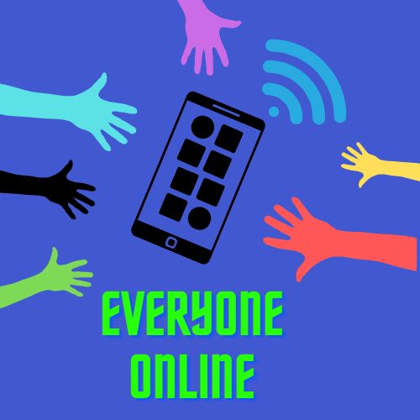

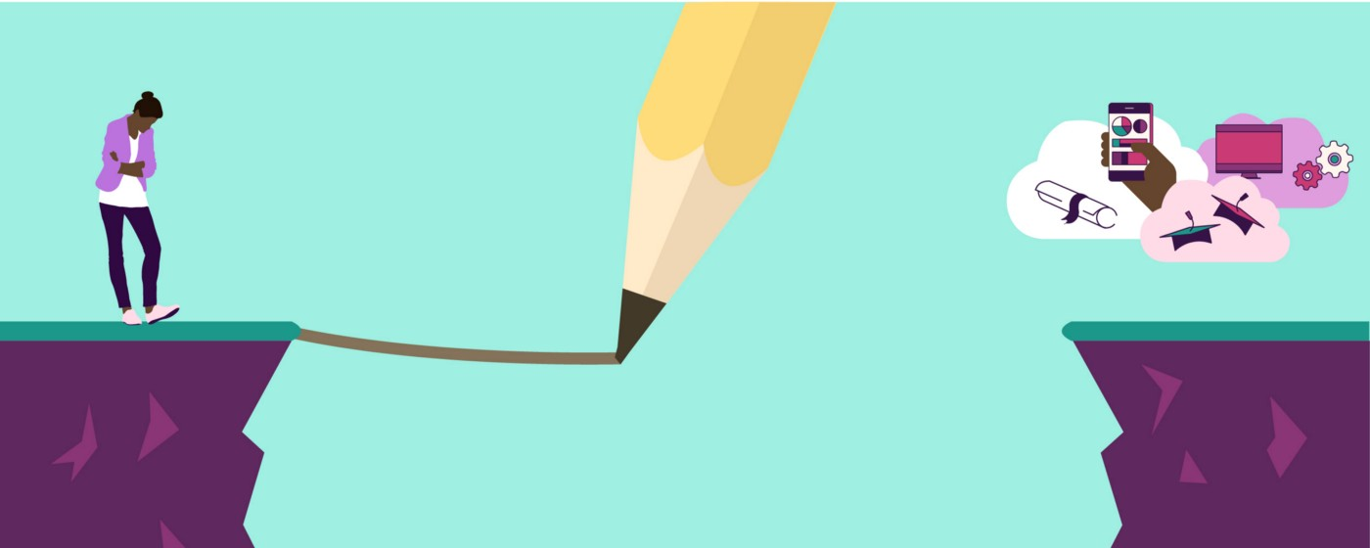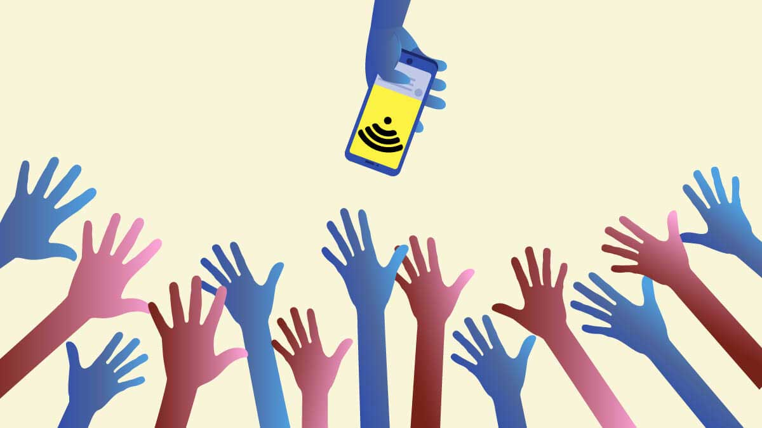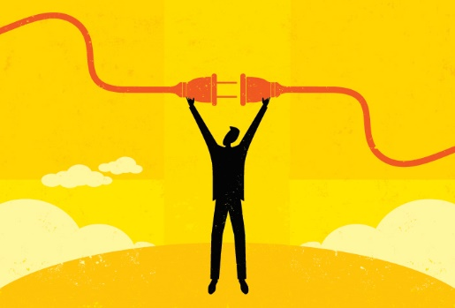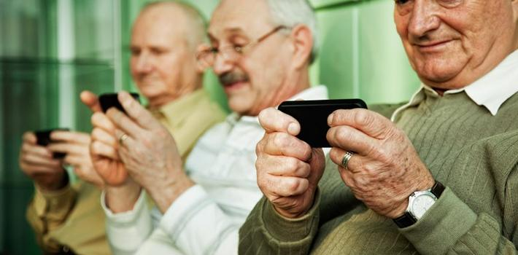

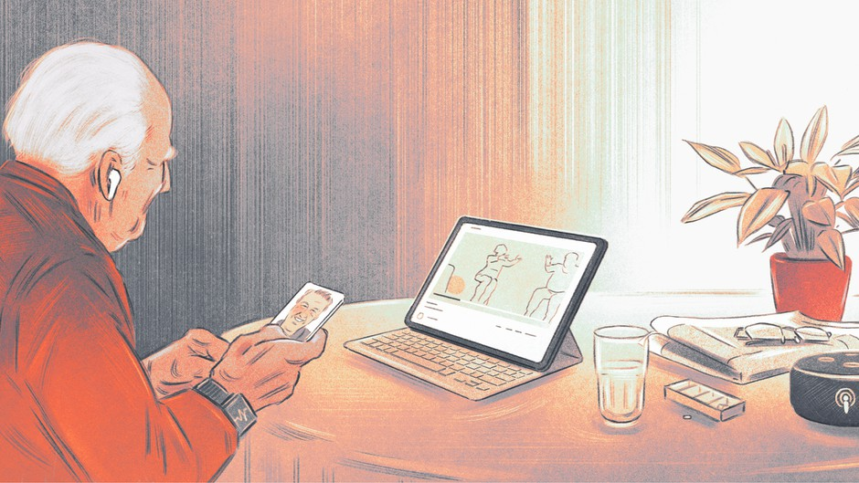

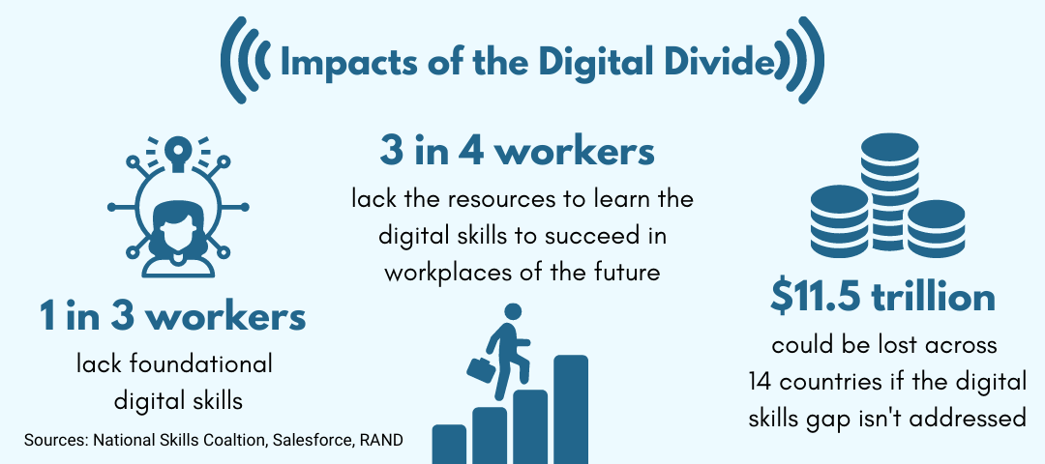

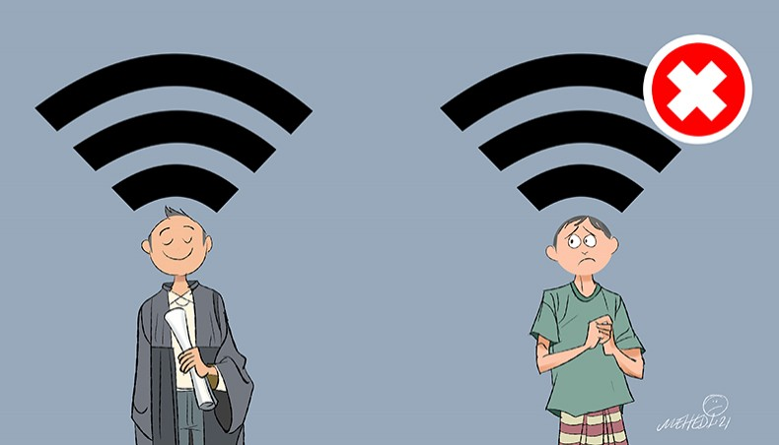

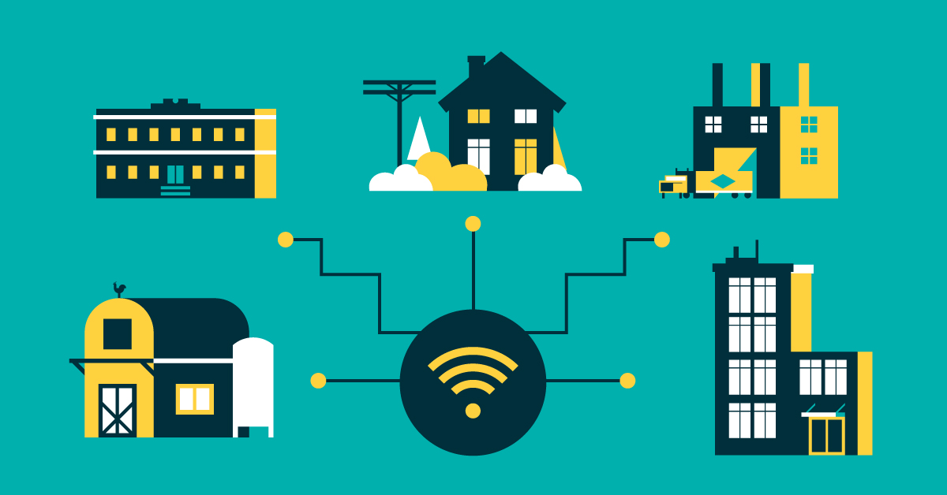

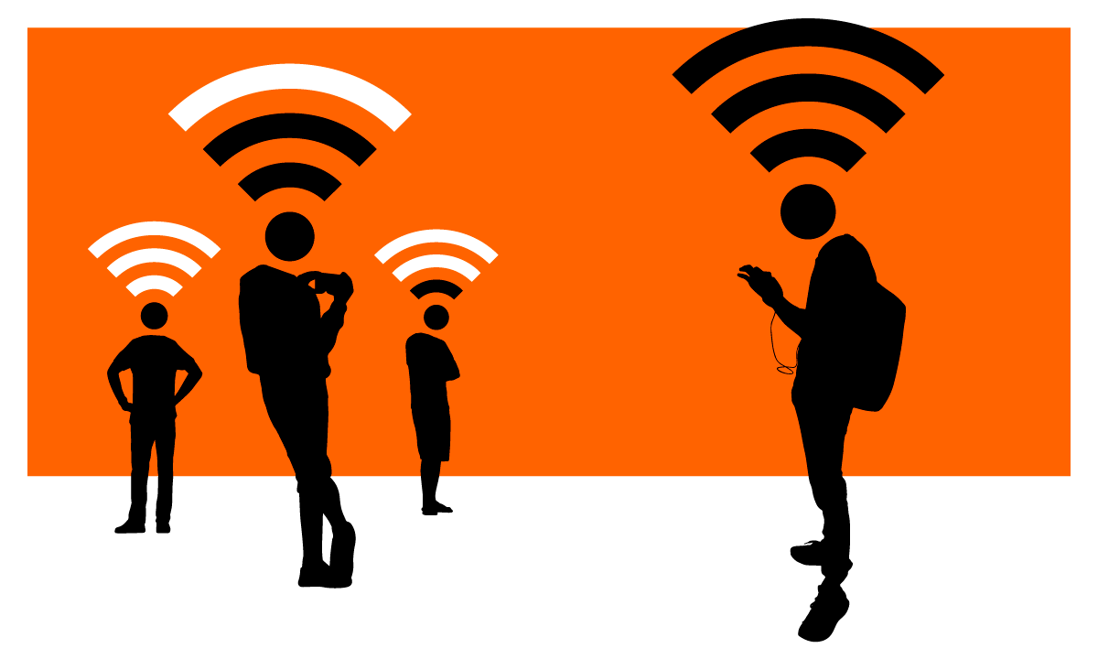

**Webpages and content:**

**Home page:**

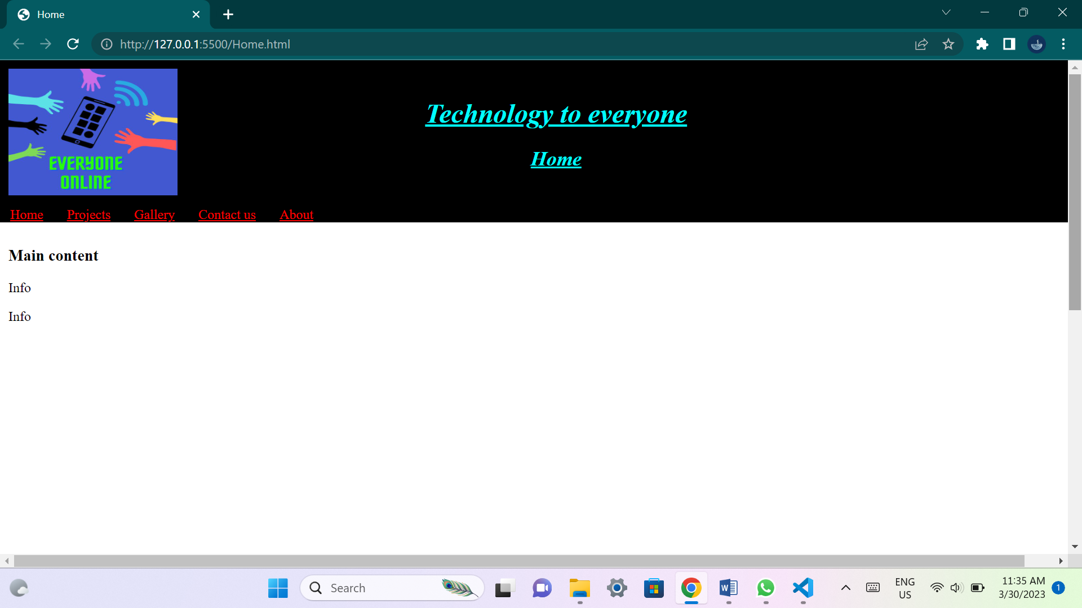

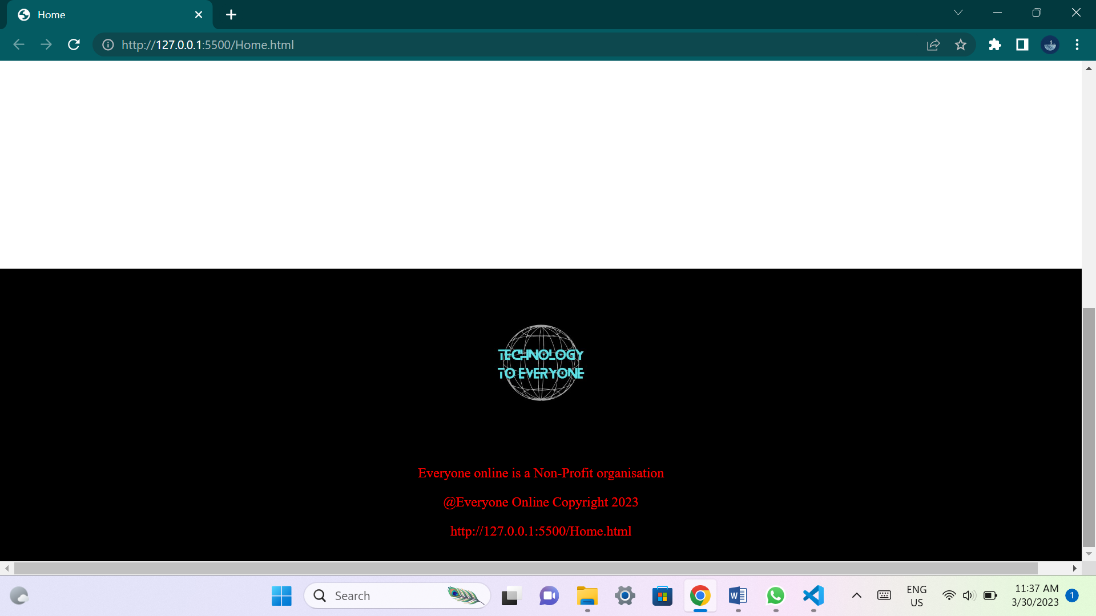

**This page will outline brief details about the organization and its plans. It will include summarized details about all the other web pages.**

**Projects page:**

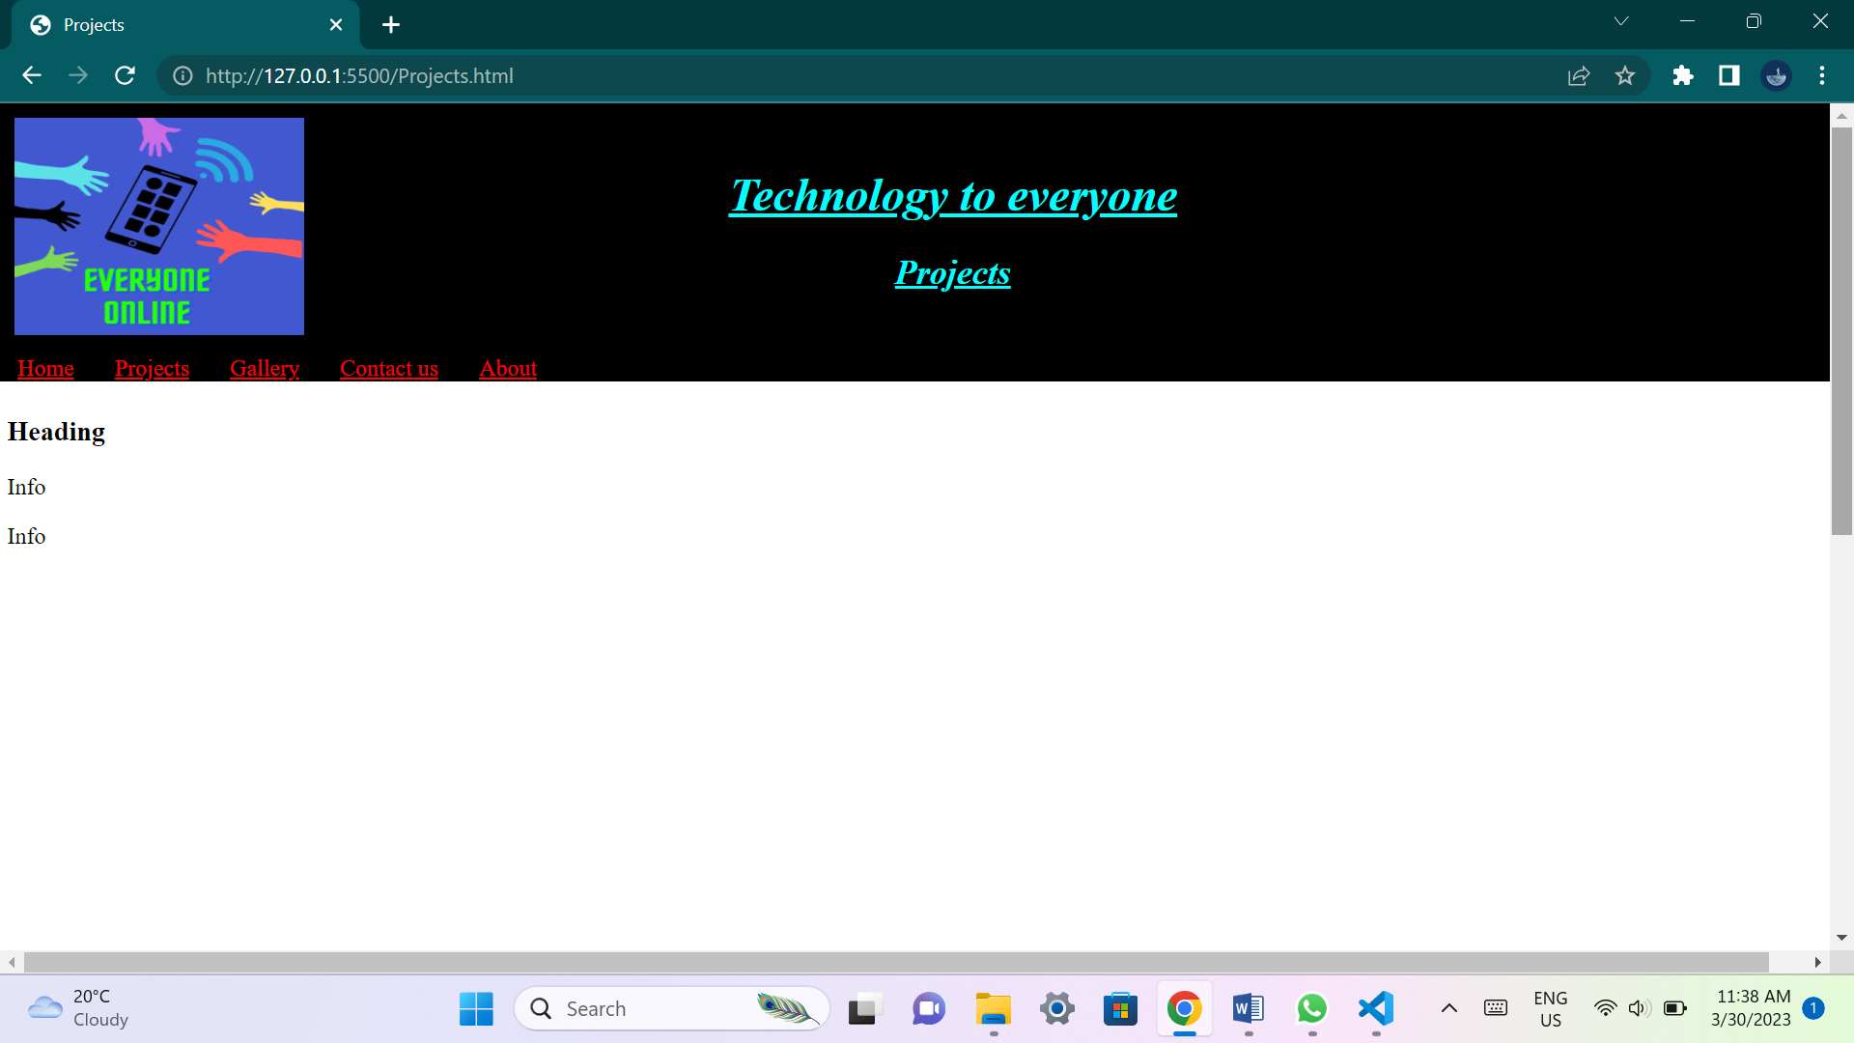

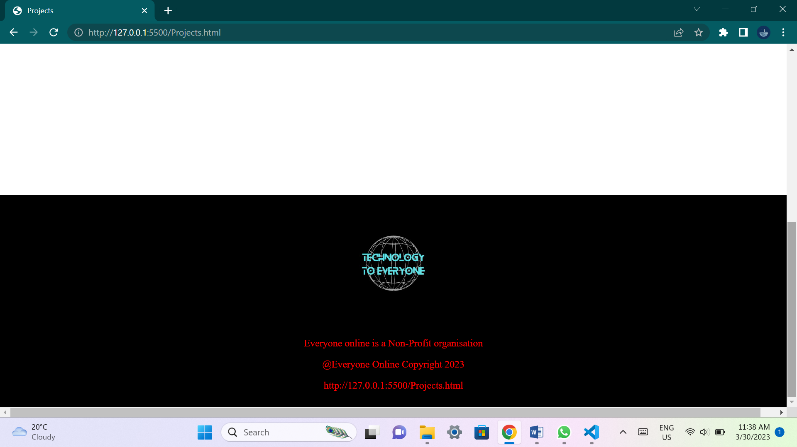

**This page will have images and details about projects that the organization is currently pursuing and wishes to accomplish.**

**Gallery page:**

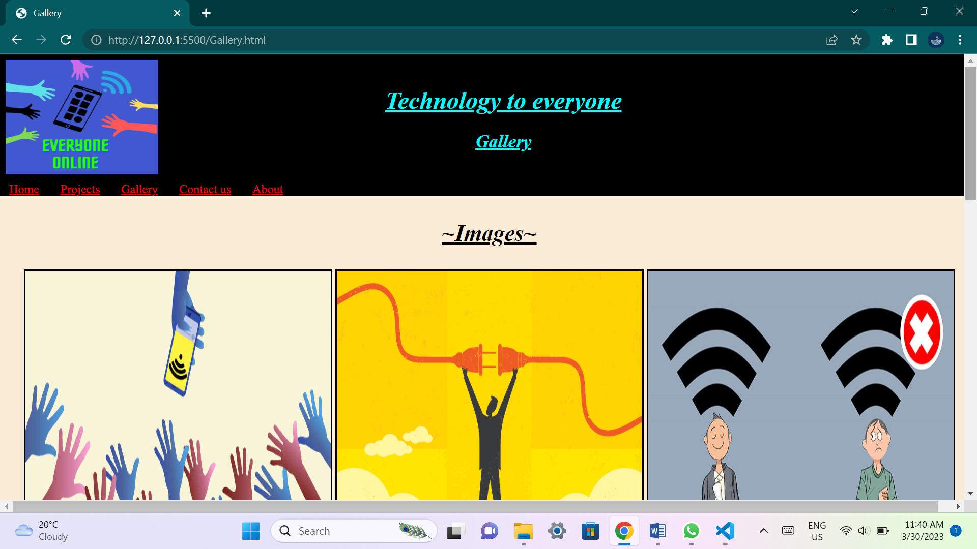

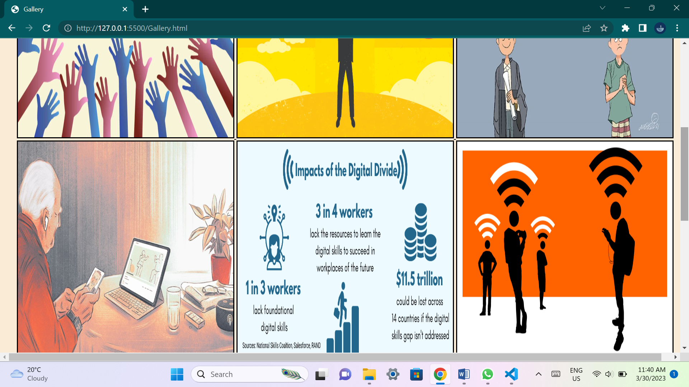

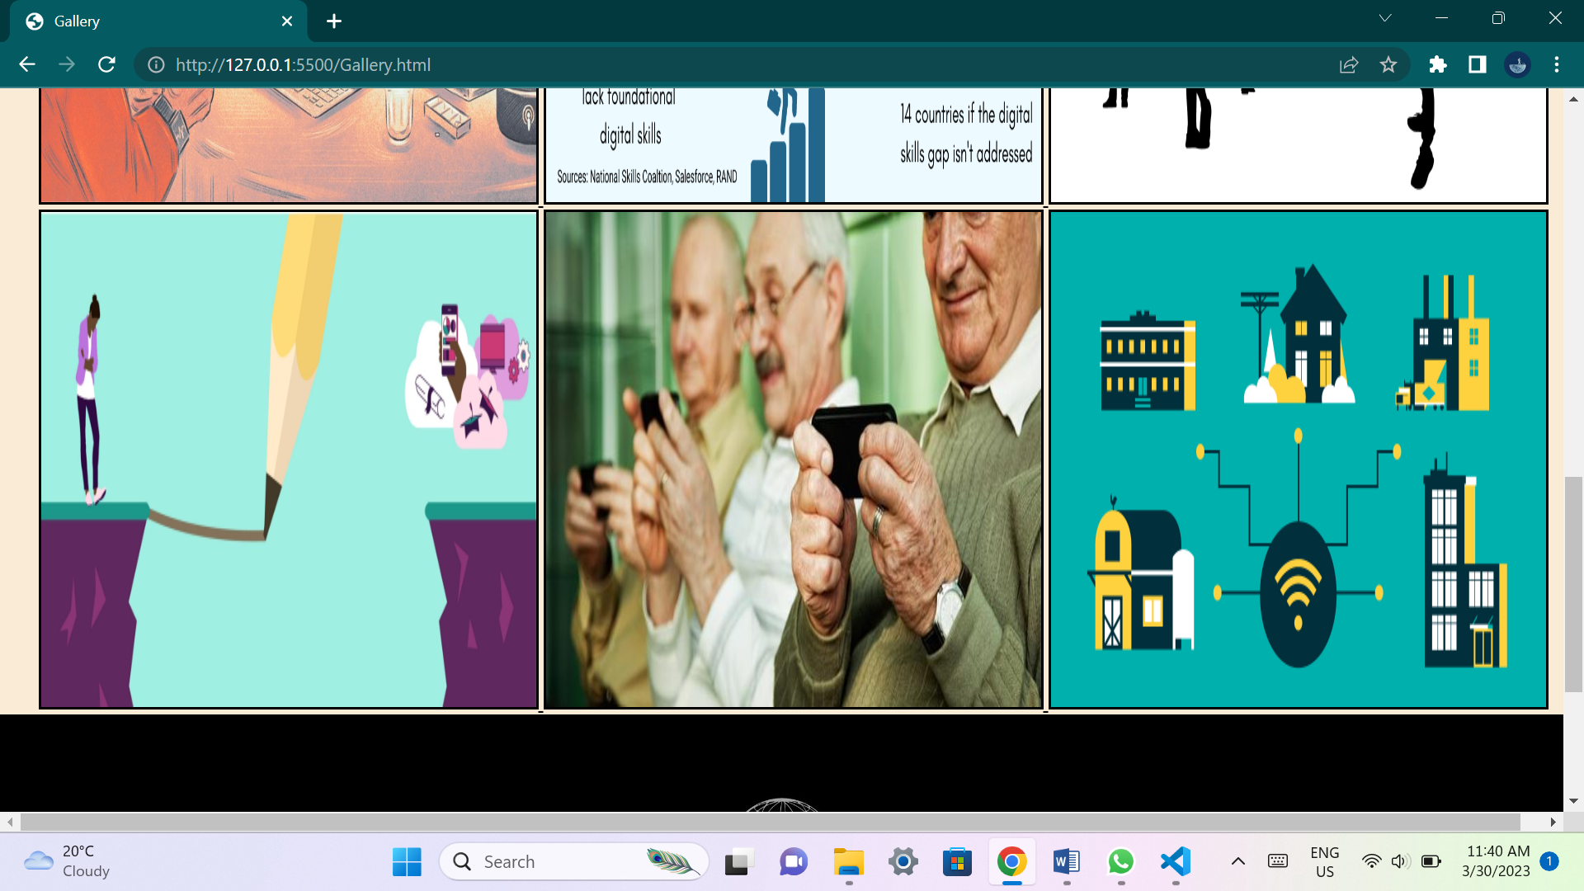

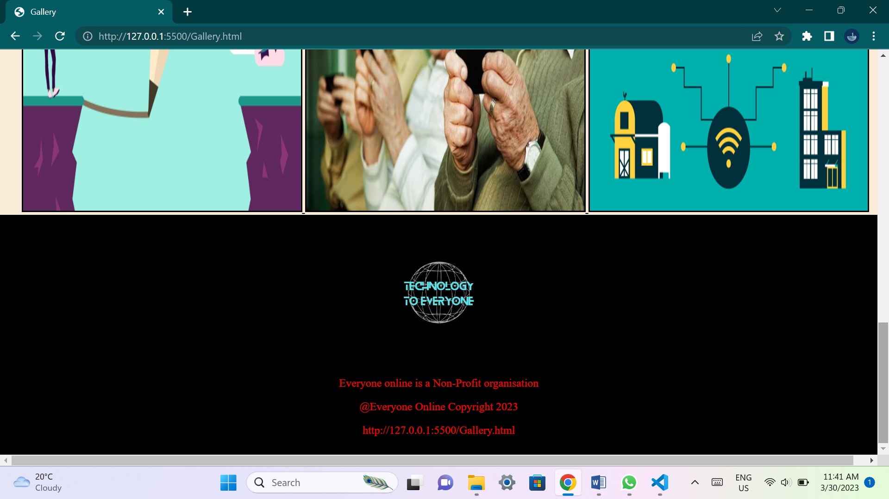

**This page will contain multiple images that would help the user understand what the organization wishes to achieve and its idea's.**

**Contact page:**

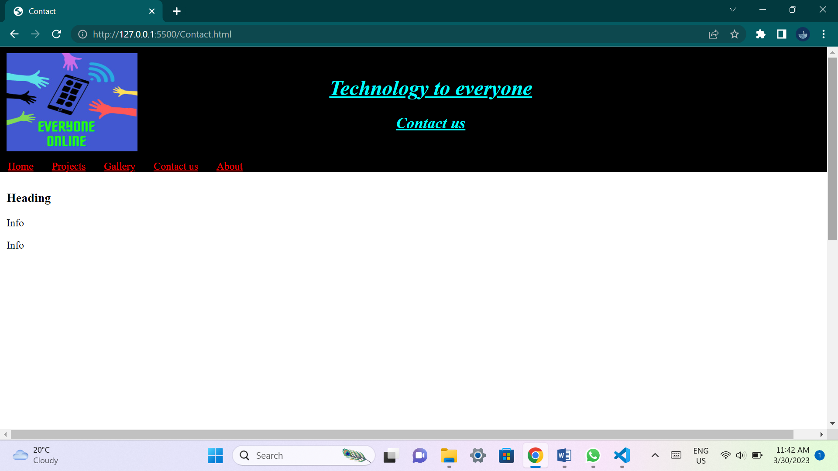

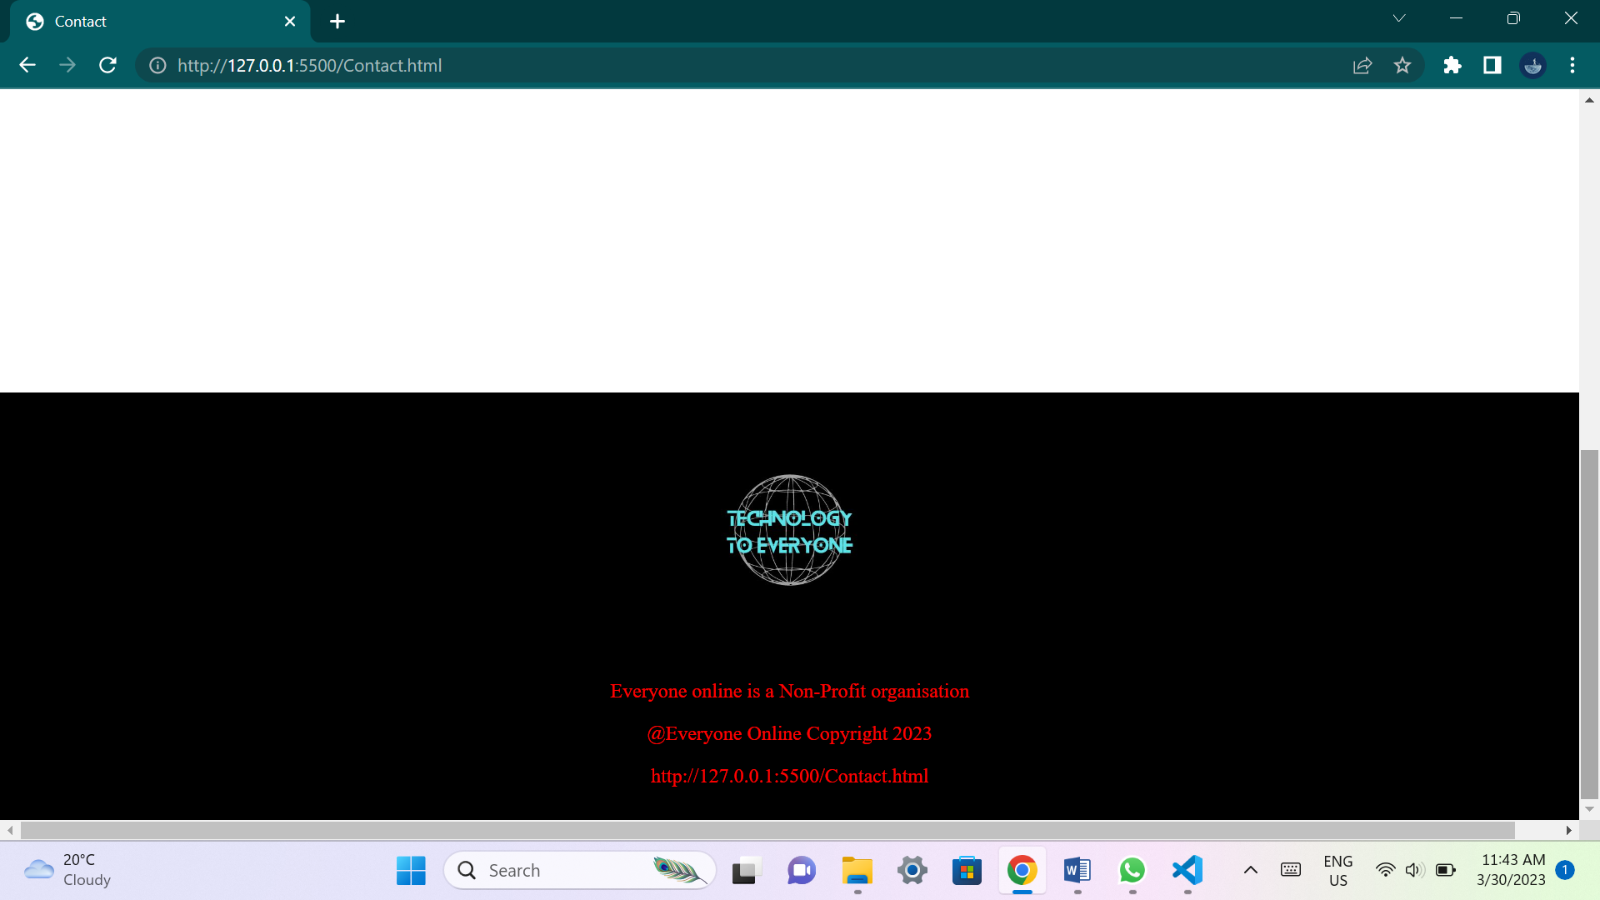

**This page will have contact details that will be available to the user if they have any questions or queries dealing with the organization.**

**About page:**

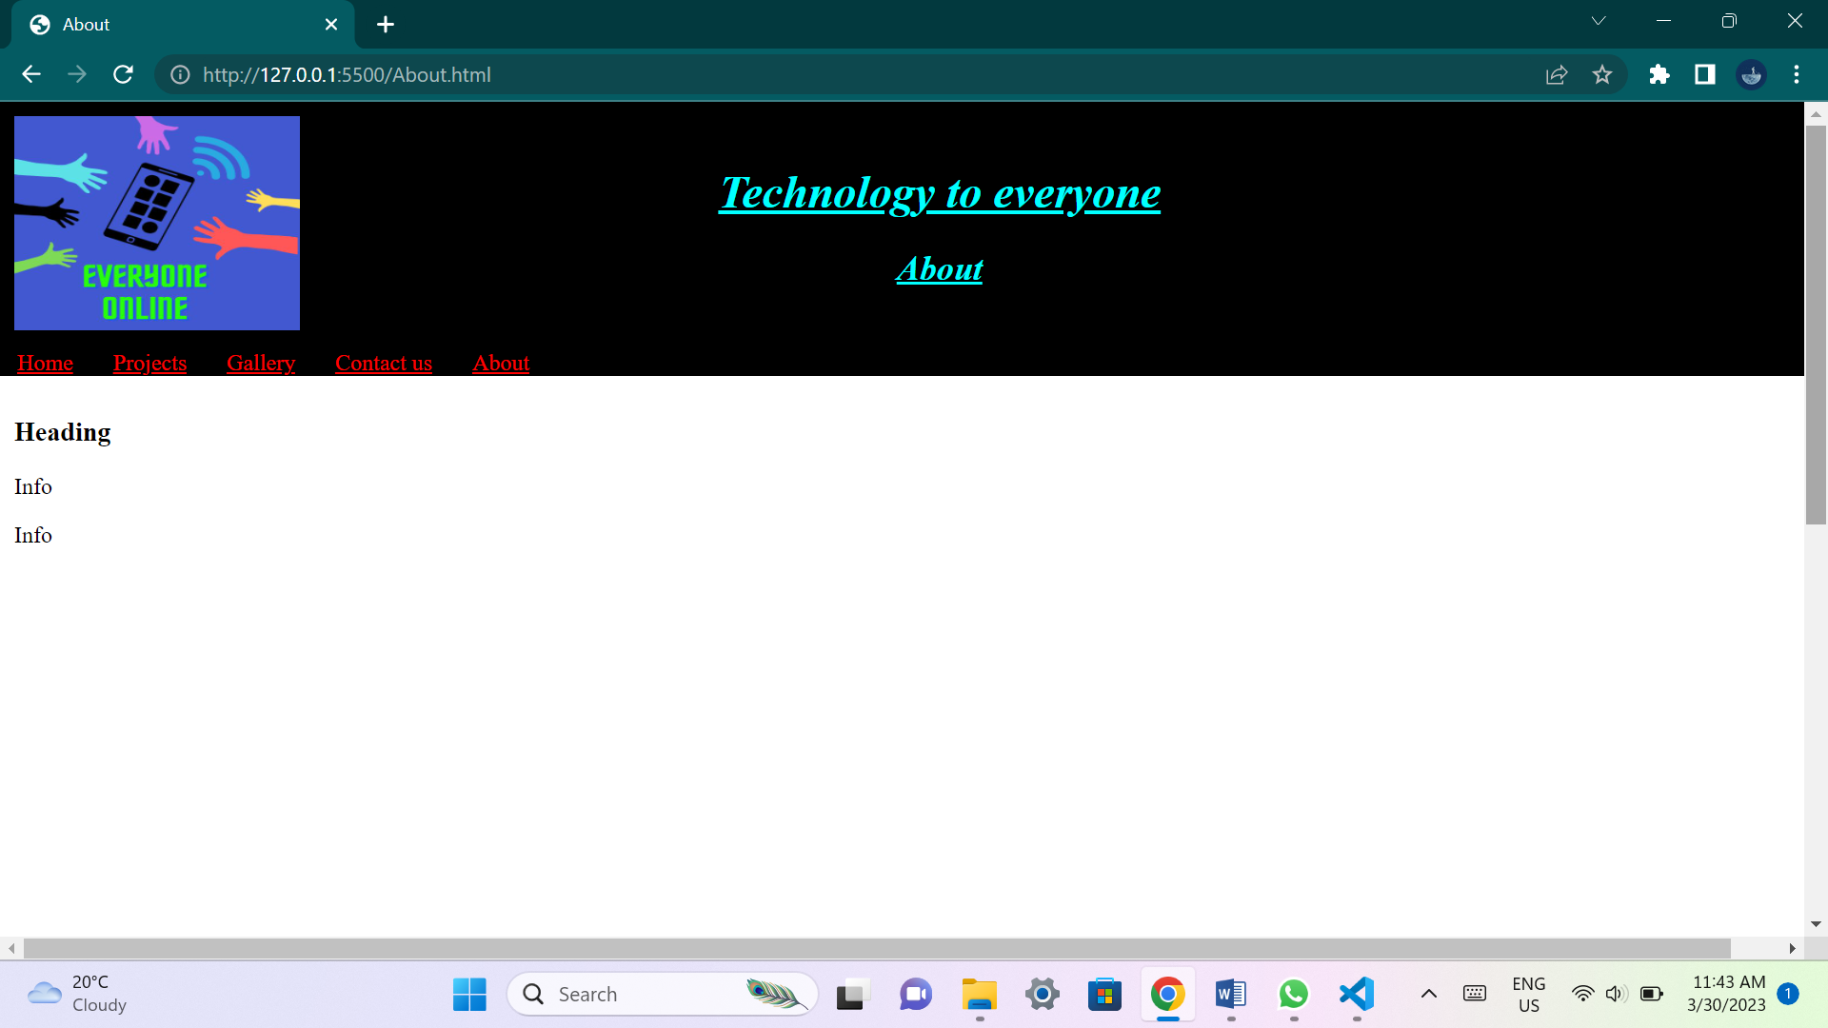

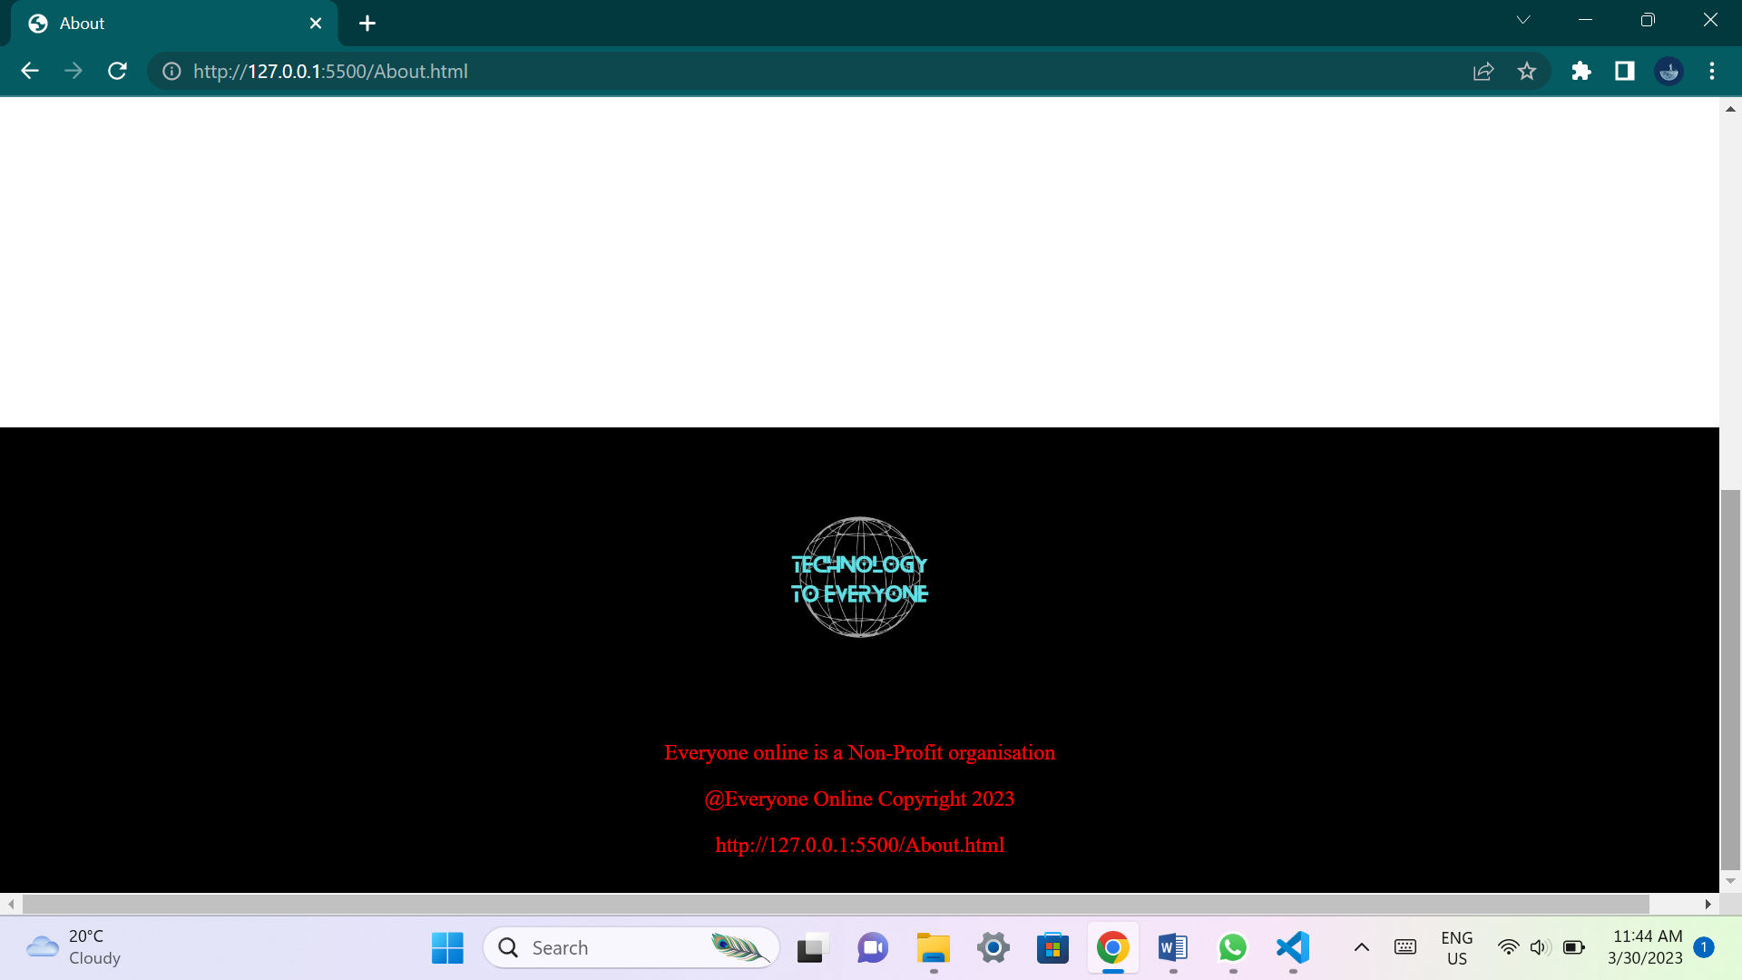

**This page will explain to the user what the organization is about. It will give users an idea about the organization goals and why the organization wants to achieve their goals.**

**List of references:**

* **Rob Amner. 2021. Digital divide narrows as 22 local schools get Wi-Fi, thanks to local tech company. 4 November 2021. [Online]. Available at:** [**https://grocotts.ru.ac.za/2021/11/04/digital-divide-narrows-as-22-local-schools-get-wi-fi-thanks-to-local-tech-company/**](https://grocotts.ru.ac.za/2021/11/04/digital-divide-narrows-as-22-local-schools-get-wi-fi-thanks-to-local-tech-company/) **(Accessed 29 March 2023)**
* **Avnation Organization. 2020. Bridging the digital divide with social activism in AV. 7 August 2020. [Online]. Available at:** [**https://www.avnation.tv/2020/08/07/bridging-the-digital-divide-with-social-activism-in-av/**](https://www.avnation.tv/2020/08/07/bridging-the-digital-divide-with-social-activism-in-av/) **(Accessed 29 March 2023)**
* **Syed Laden. 2021. Digital Bangladesh, digital divide and education sector. 18 April 2021. [Online]. Available at:** [**https://www.newagebd.net/article/135620/digital-bangladesh-digital-divide-and-education-sector**](https://www.newagebd.net/article/135620/digital-bangladesh-digital-divide-and-education-sector) **(Accessed 29 March 2023)**
* **Linda Poon and Sarah Holder. 2020. The ‘New Normal’ for Many Older Adults Is on the Internet. 6 May 2020. [Online]. Available at:** [**https://www.bloomberg.com/news/features/2020-05-06/in-lockdown-seniors-are-becoming-more-tech-savvy**](https://www.bloomberg.com/news/features/2020-05-06/in-lockdown-seniors-are-becoming-more-tech-savvy) **(Accessed 29 March 2023)**
* **Keith Oelrich. 2022. Why We Must Close the Digital Divide. 15 February 2022. [Online]. Available at:** [**https://www.learning.com/blog/closing-the-digital-divide/**](https://www.learning.com/blog/closing-the-digital-divide/) **(Accessed 29 March 2023)**
* **Joshua Bay. 2022. Report: Internet Gap Snubs LA Low-Income Residents & Widens Digital Divide. 24 October 2022. Available at:** [**https://www.the74million.org/article/report-internet-gap-snubs-la-low-income-residents-widens-digital-divide/**](https://www.the74million.org/article/report-internet-gap-snubs-la-low-income-residents-widens-digital-divide/) **(Accessed 29 March 2023)**
* **Ally Tech. 2022. Bridging the Digital Divide: Driving Towards Digital Equity & Inclusion for All. 19 August 2022. Available at:** [**https://ally.tech/bridging-the-digital-divide-driving-towards-digital-equity-inclusion-for-all-fb519aaaca0a**](https://ally.tech/bridging-the-digital-divide-driving-towards-digital-equity-inclusion-for-all-fb519aaaca0a) **(Accessed 29 March 2023)**
* **Theodore D Cosco. 2018. Bridging the digital divide amongst older adults. 23 May 2018. Available at:** [**https://www.ageing.ox.ac.uk/blog/digital-divide**](https://www.ageing.ox.ac.uk/blog/digital-divide) **(Accessed 29 March 2023)**
* **Admin. 2020. THE DIGITAL DIVIDE. 6 October 2020. Available at:** [**https://www.rebdones.com/uncategorized/the-digital-divide/**](https://www.rebdones.com/uncategorized/the-digital-divide/) **(Accessed 29 March 2023)**

**Part 2:**

**Improvements to part 1:**

**New website assets:**

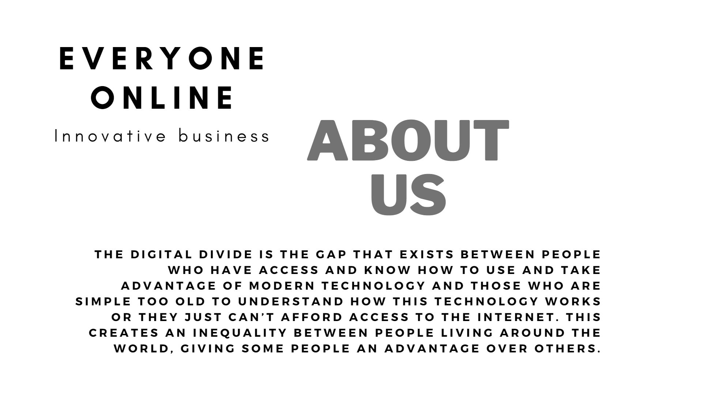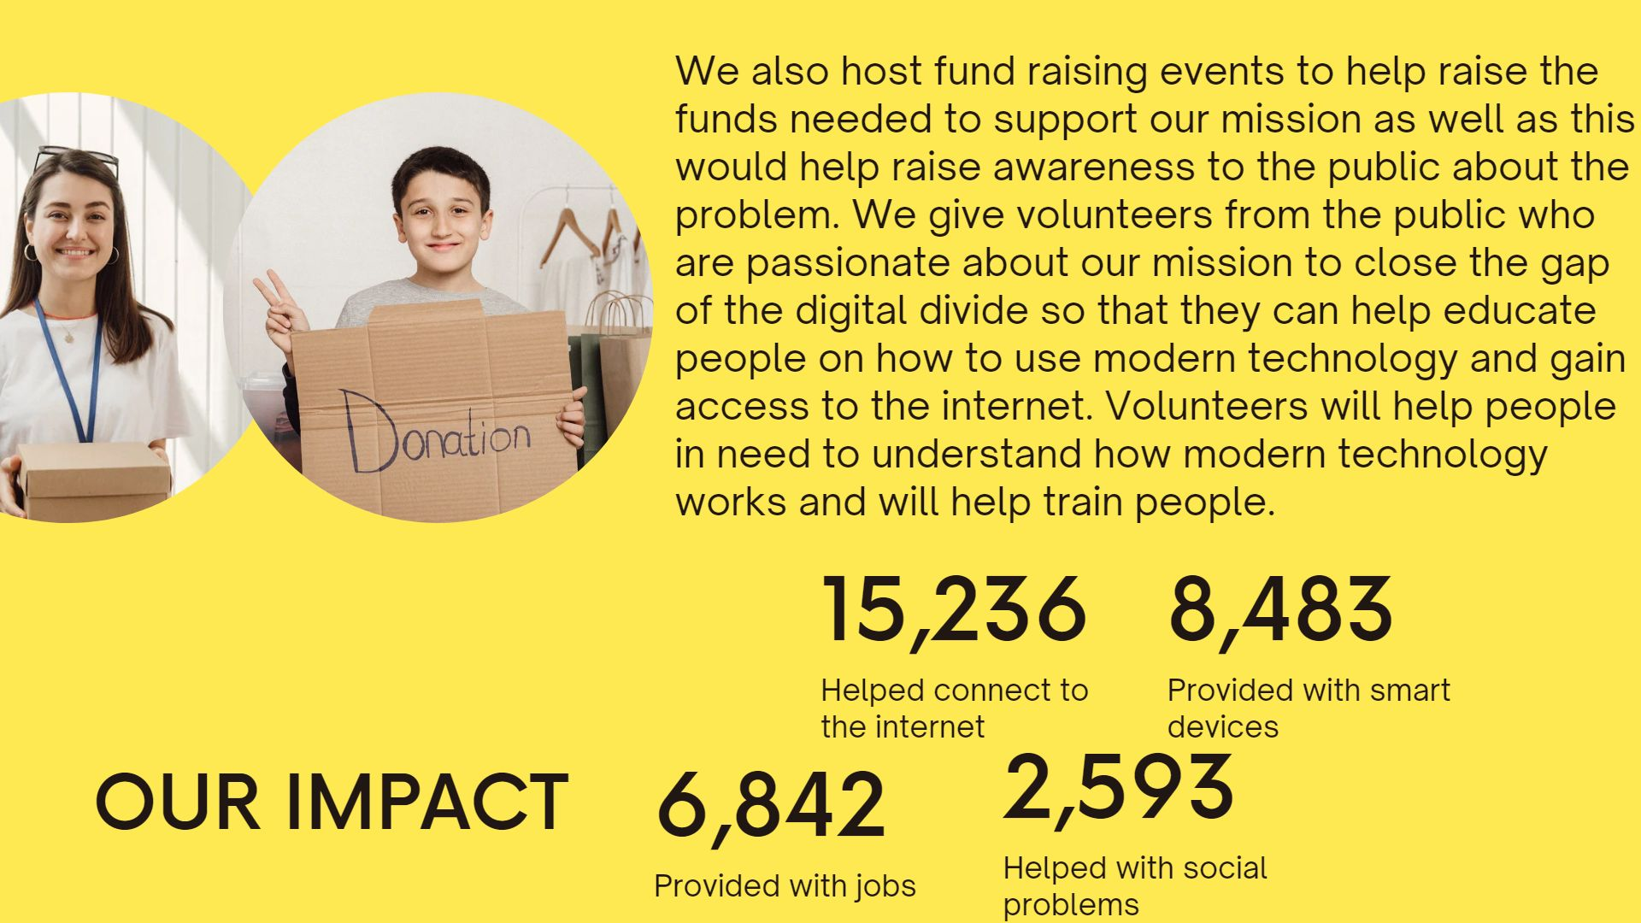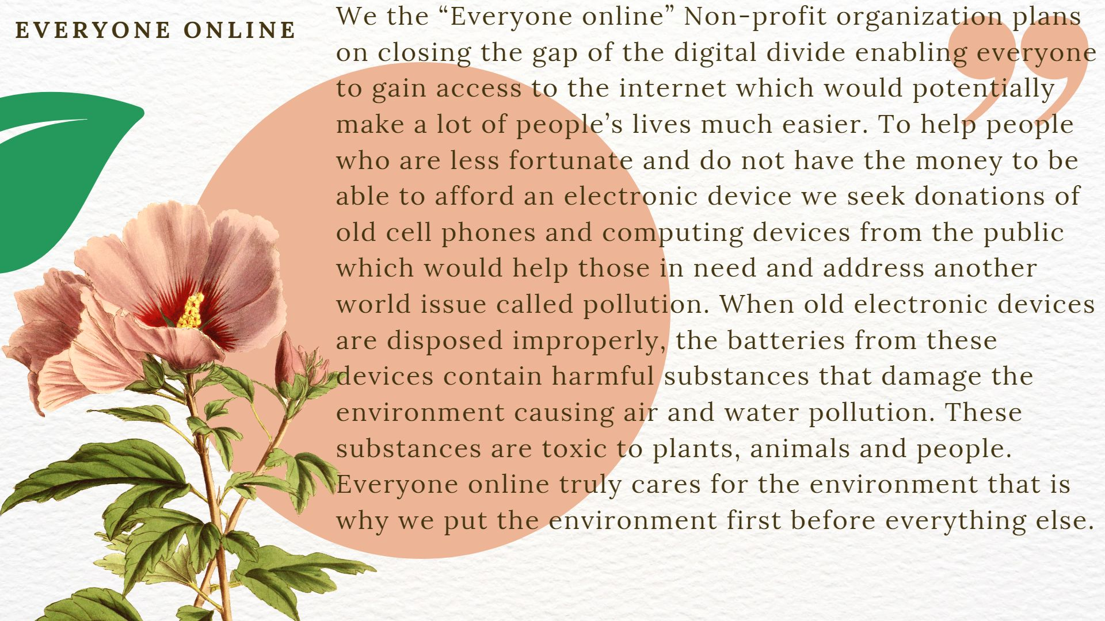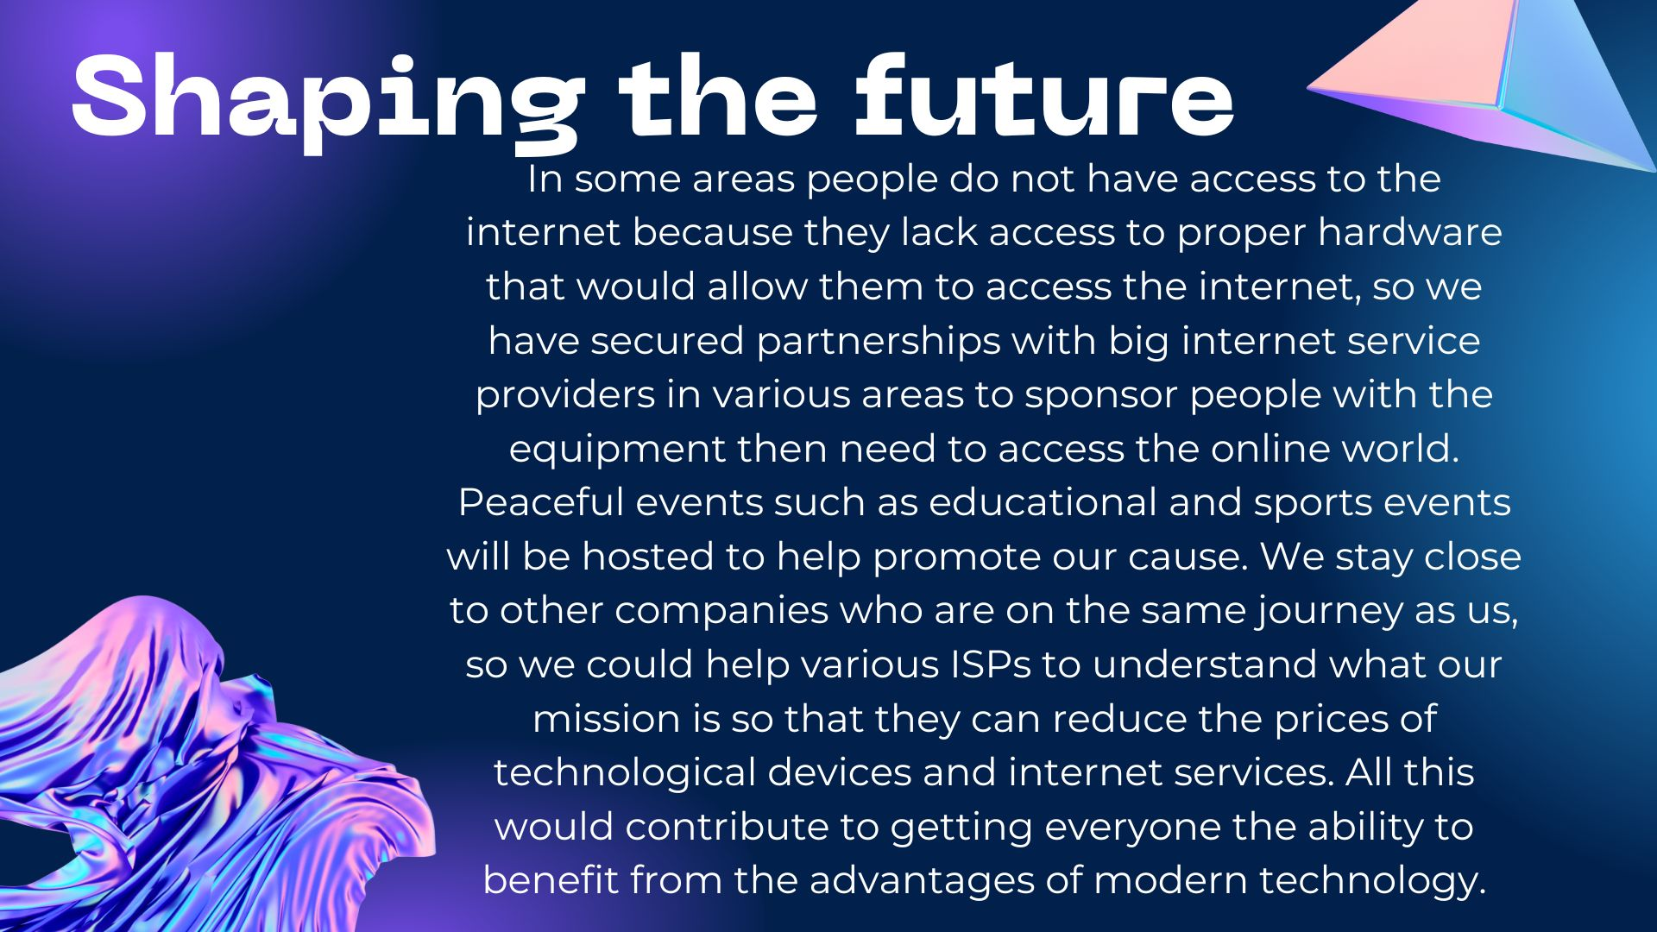

























**All new material was designed using Canva application.**

**Improved webpages and content:**

**Home page:**

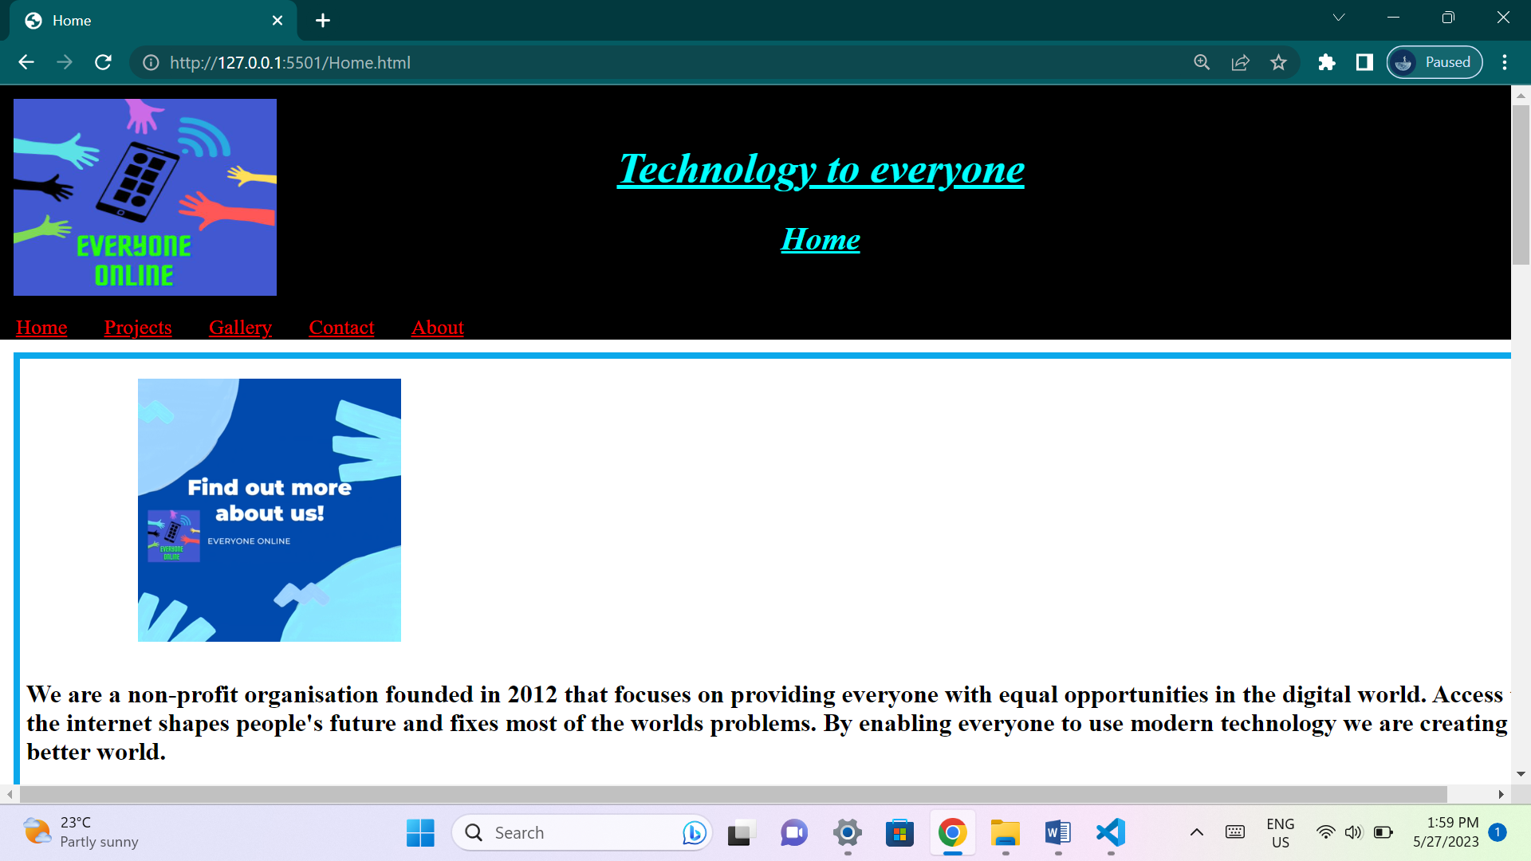

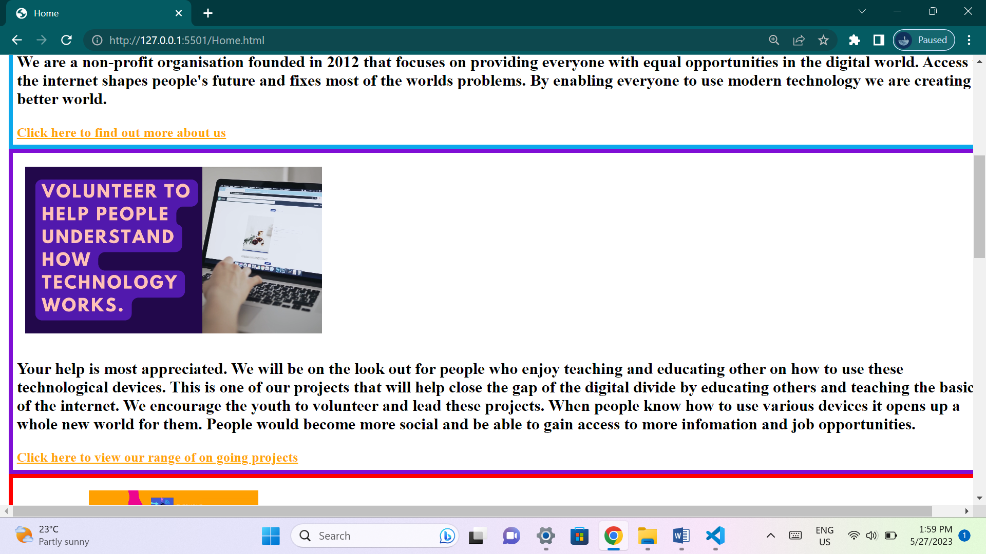

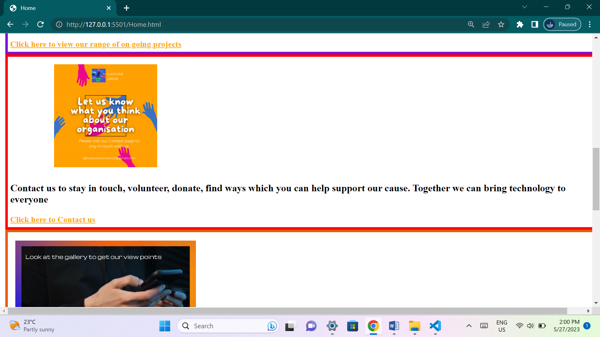

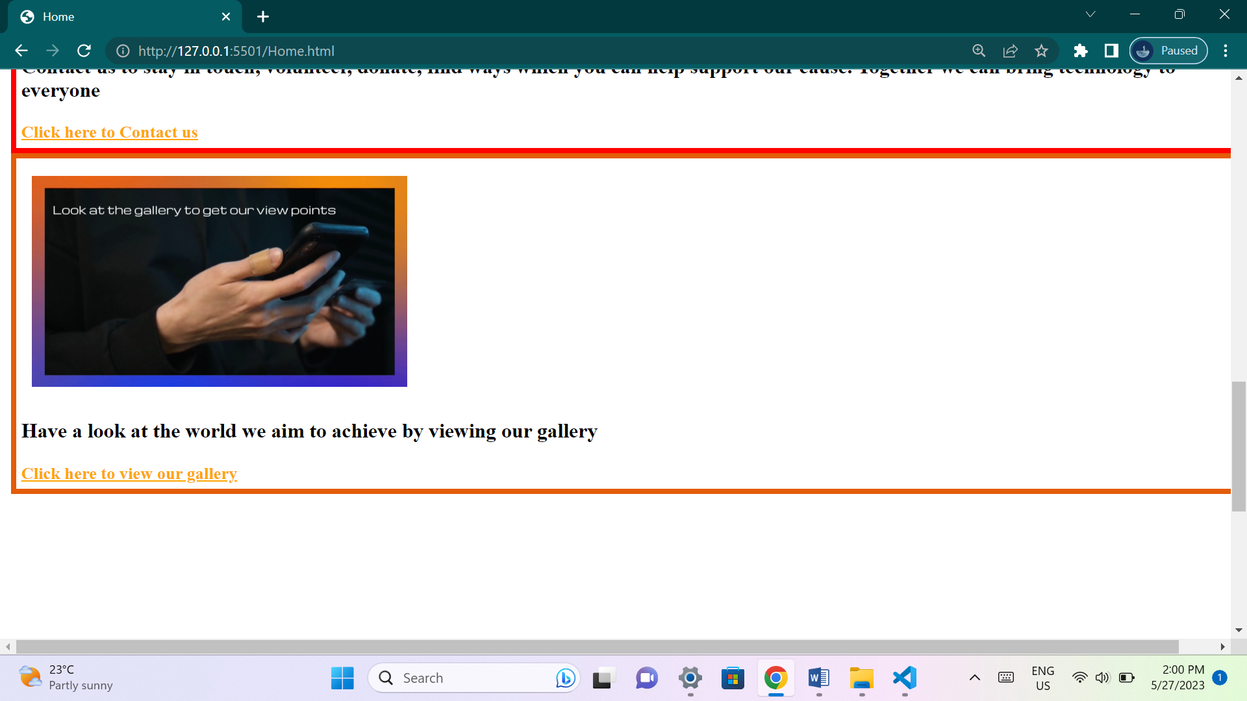

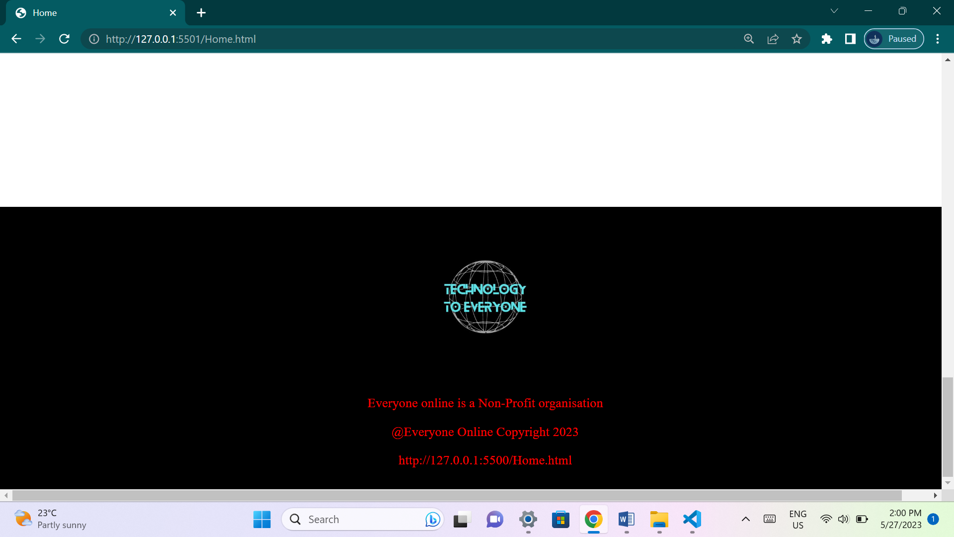

**This page has outline brief details about the organization and its plans. It includes summarized details about all the other web pages as well as links to other pages.**

**Projects page:**

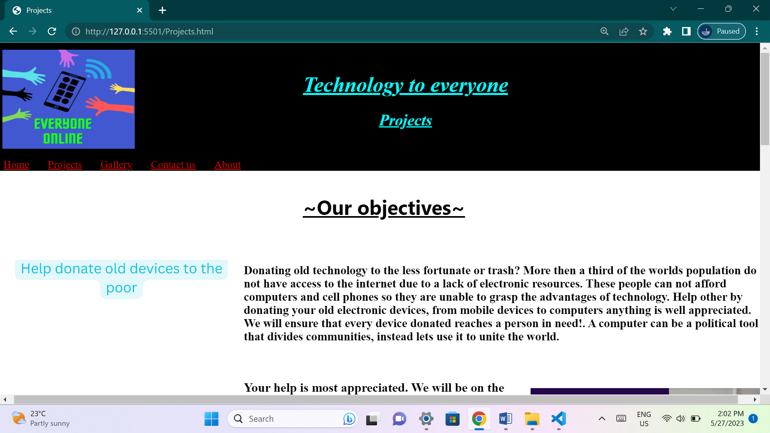

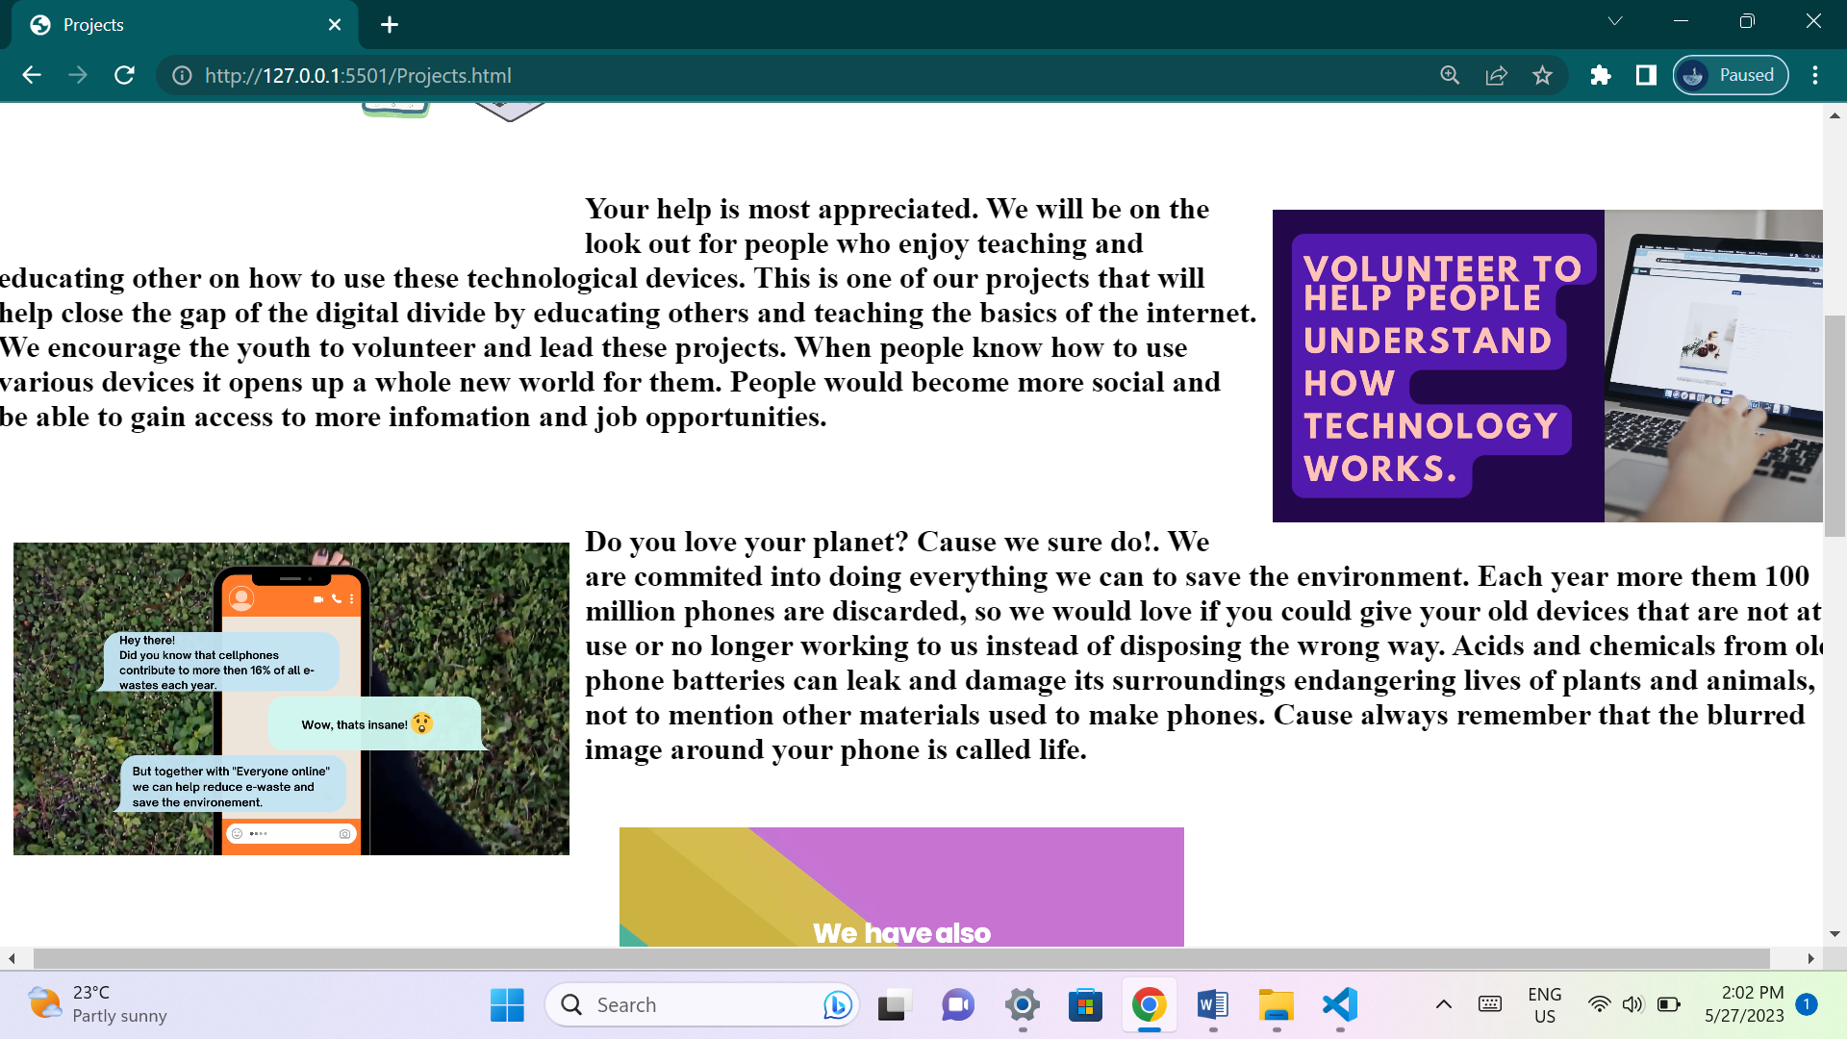

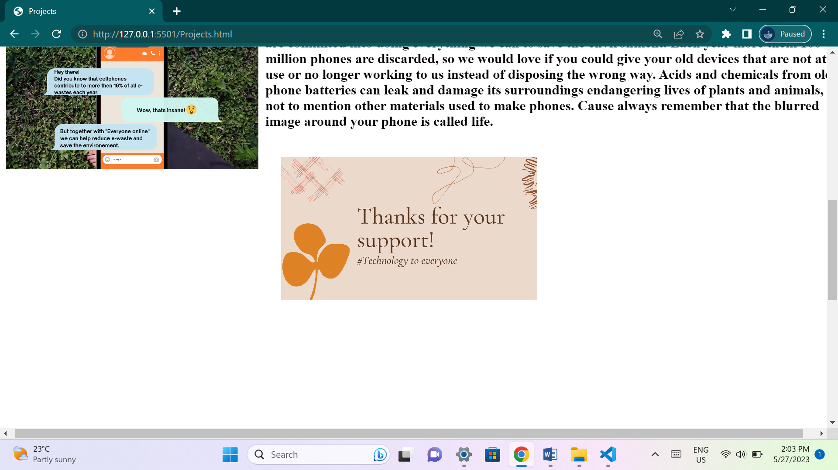

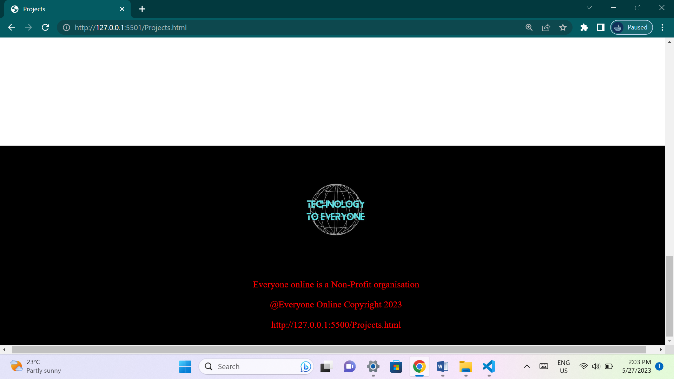

**This page has videos and details about projects that the organization is currently pursuing and wishes to accomplish.**

**Gallery page:**

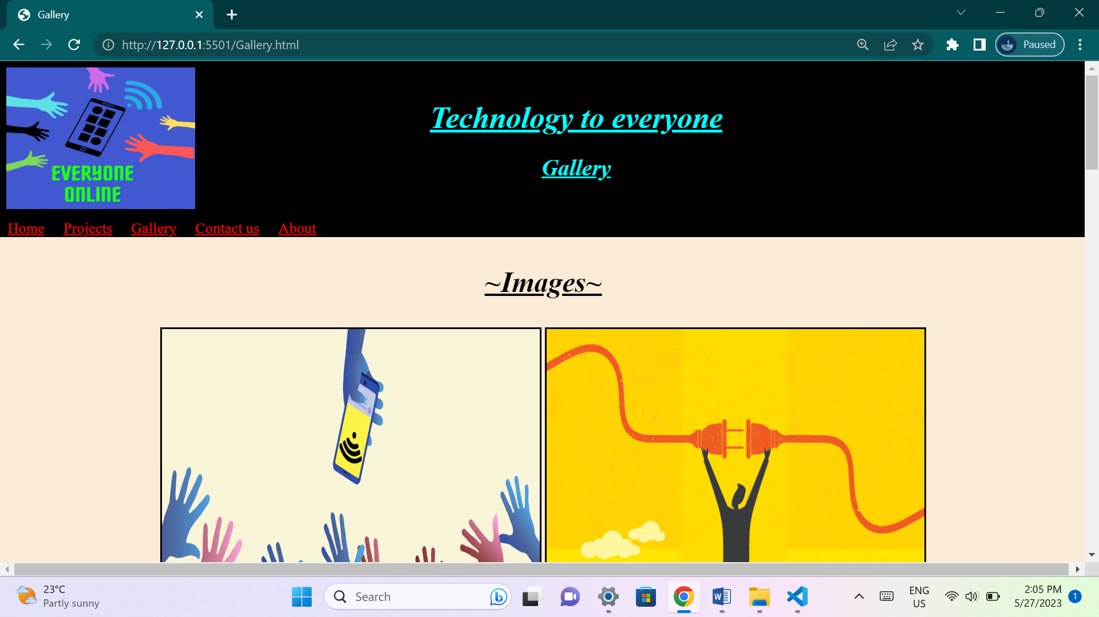

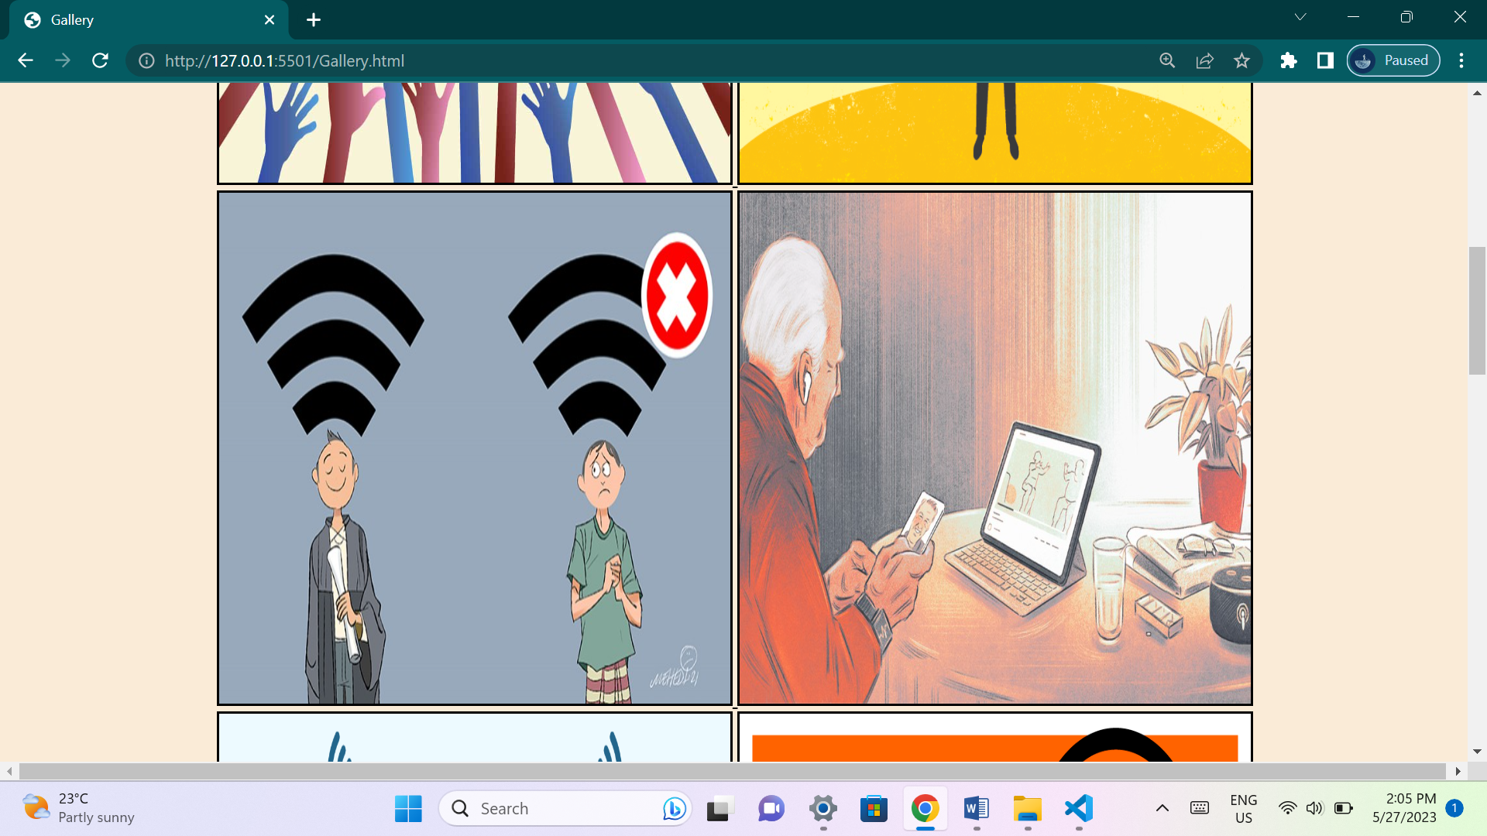

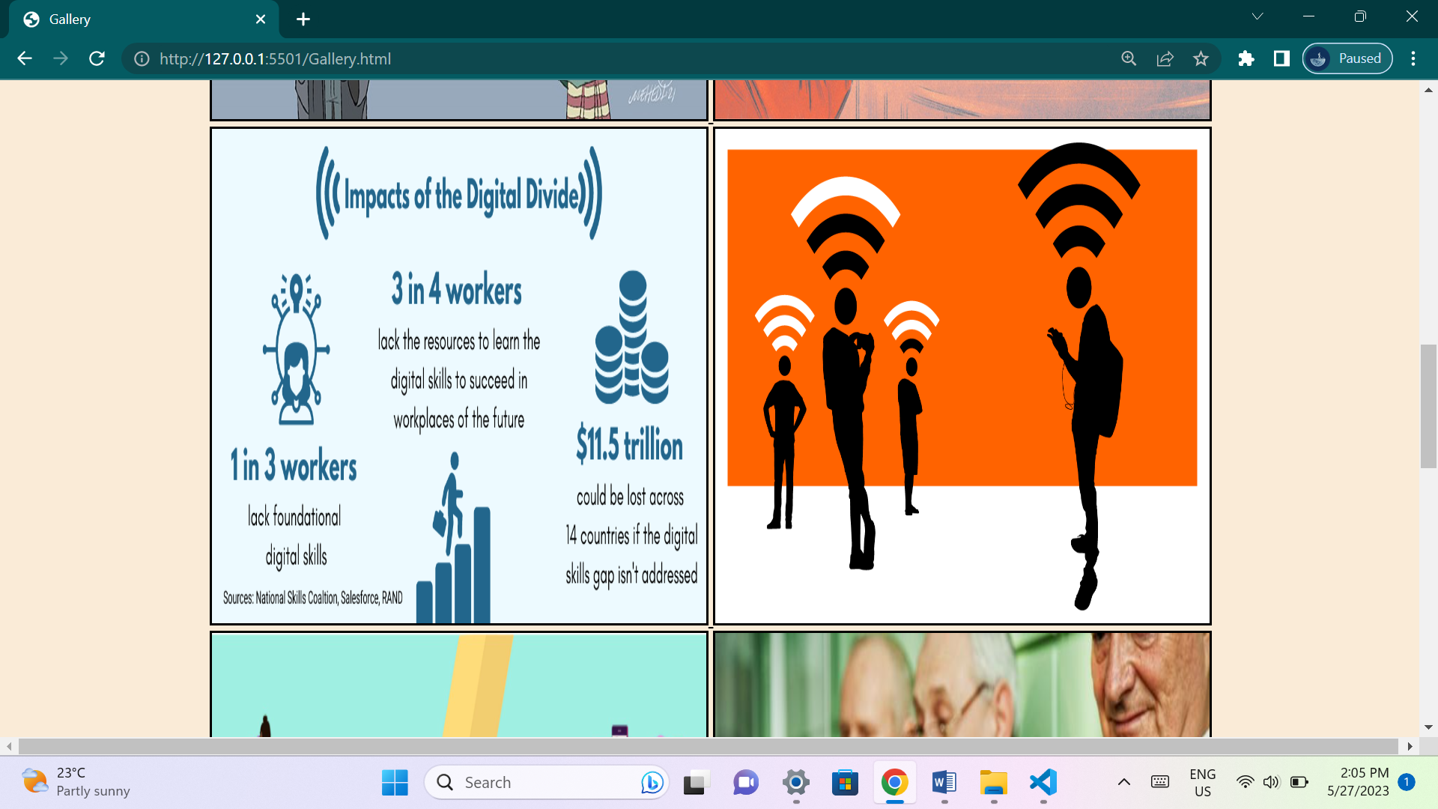

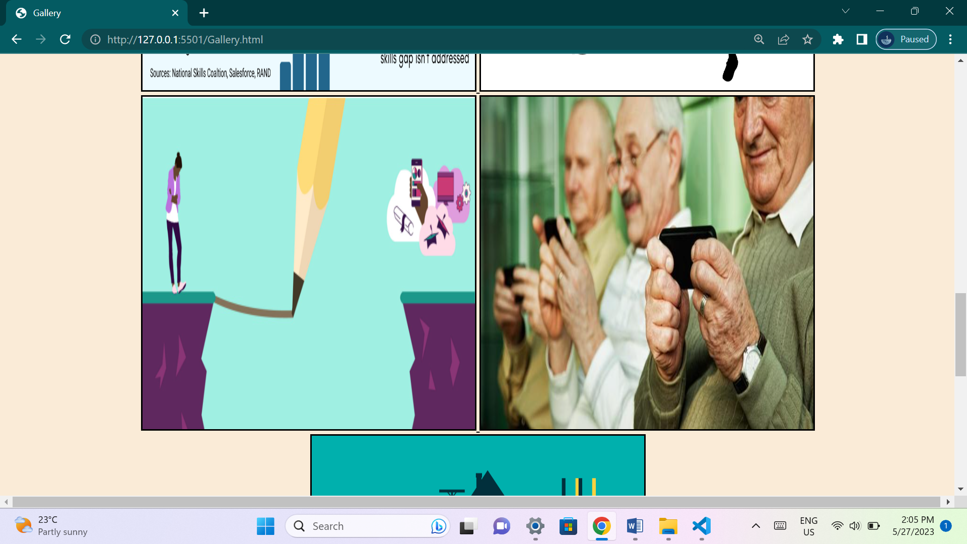

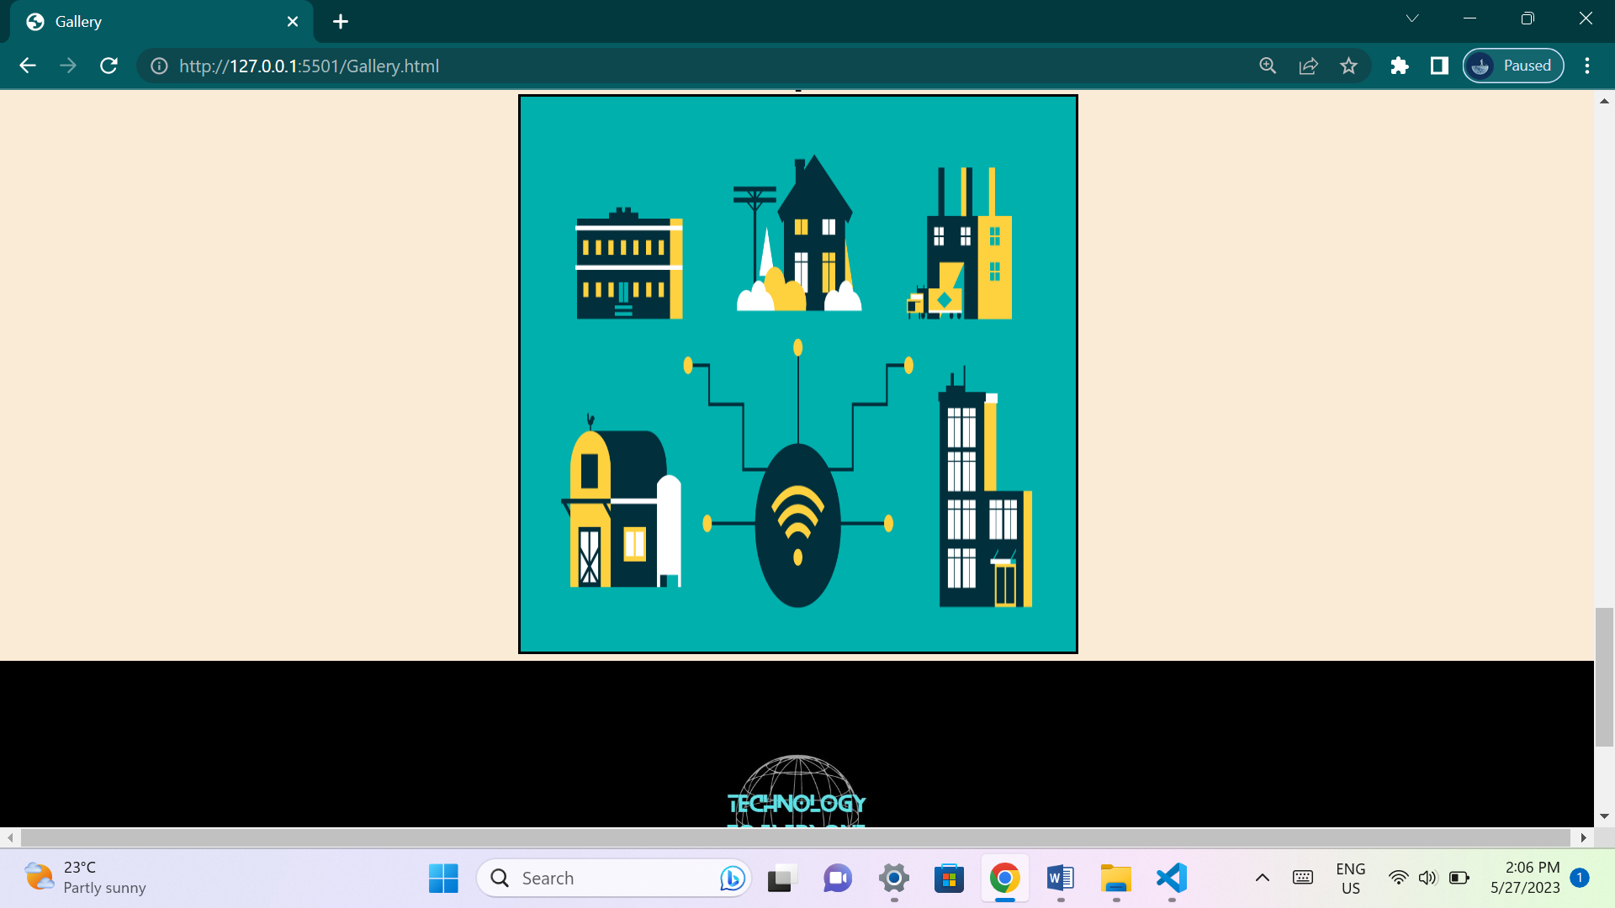

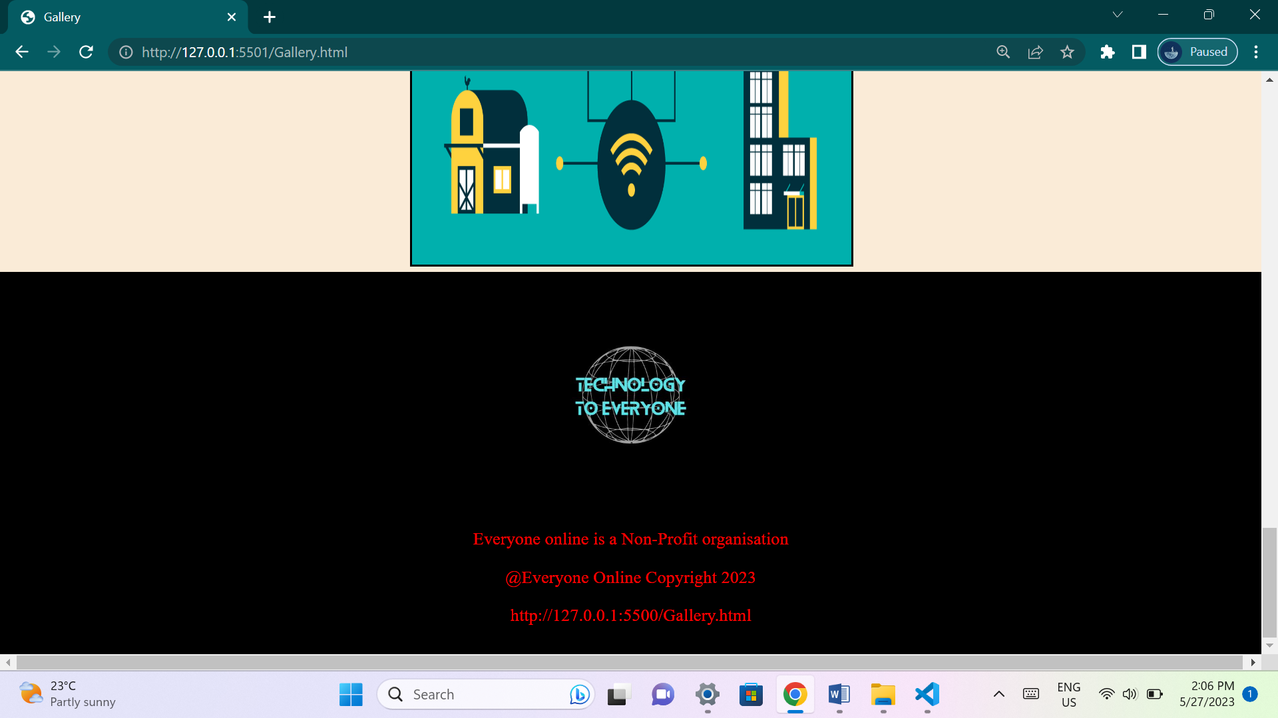

**This page contains multiple images that would help the user understand what the organization wishes to achieve, and its idea's.**

**Contact us page:**

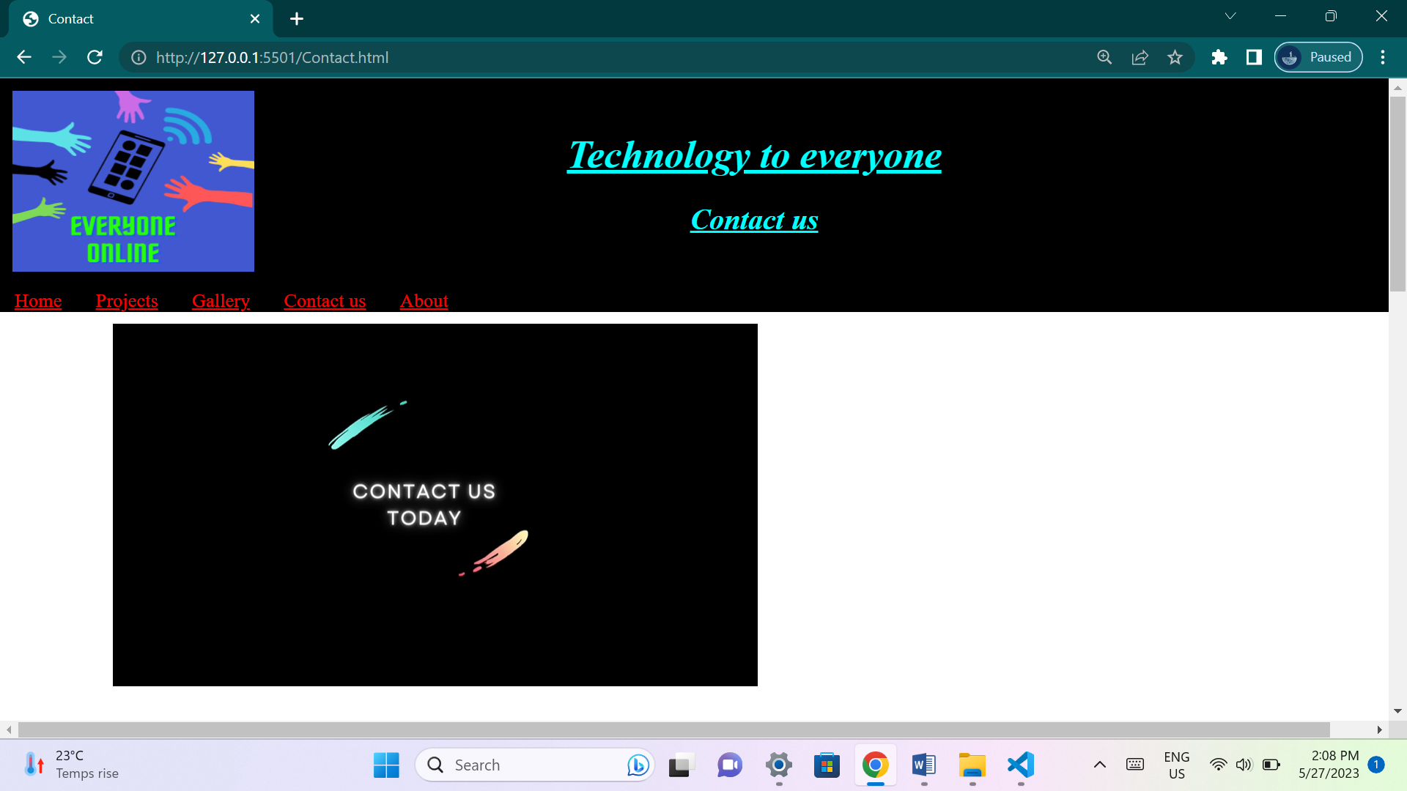

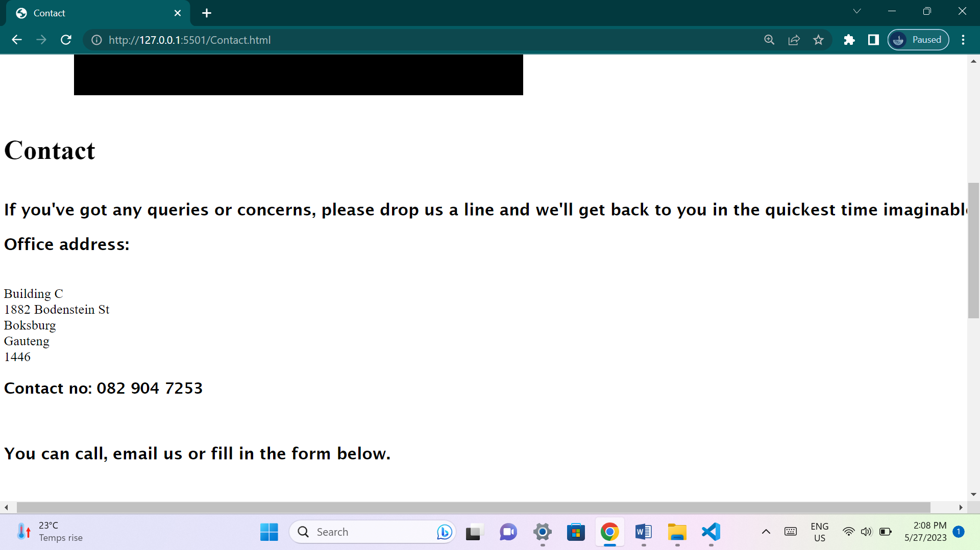

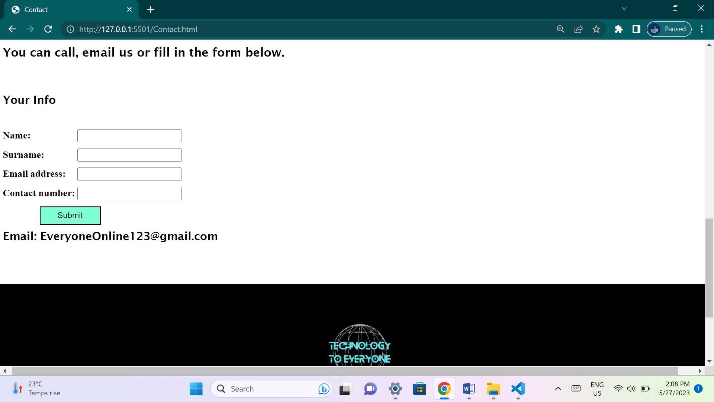

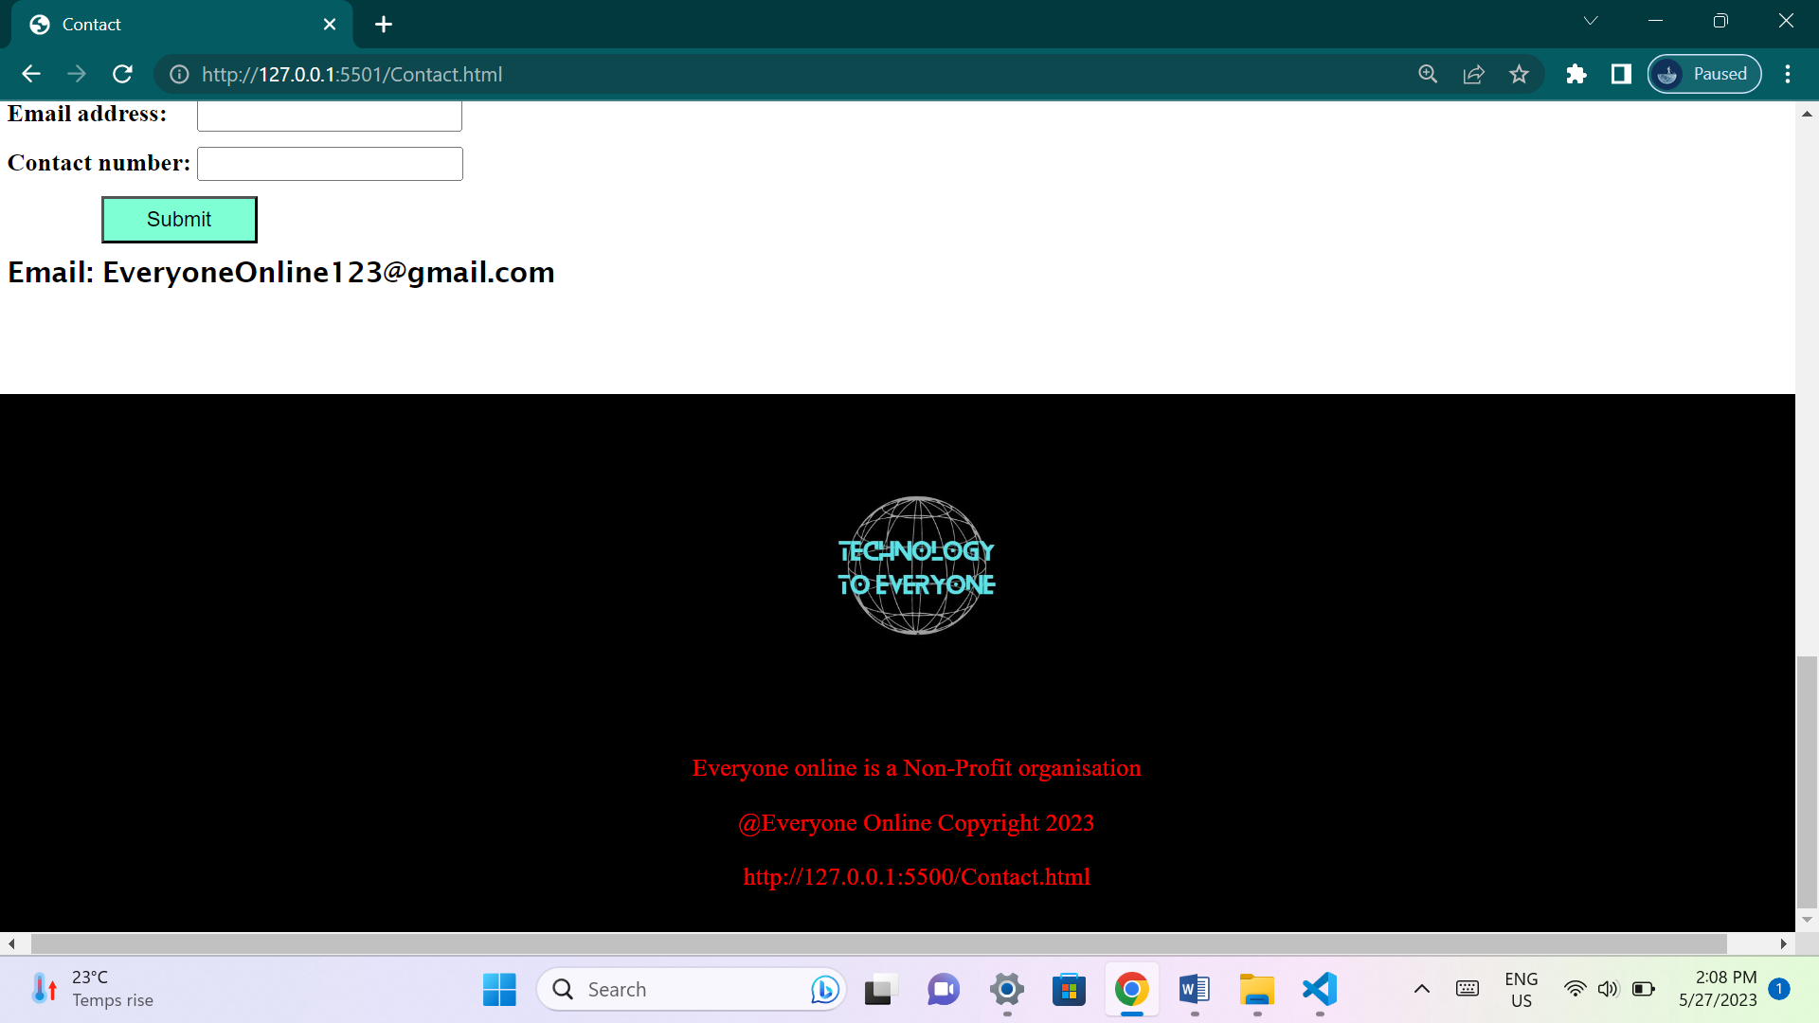

**This page has contact details that will be available to the user if they have any questions or queries dealing with the organization. A page that allows users to stay in touch with the organization.**

**About page:**

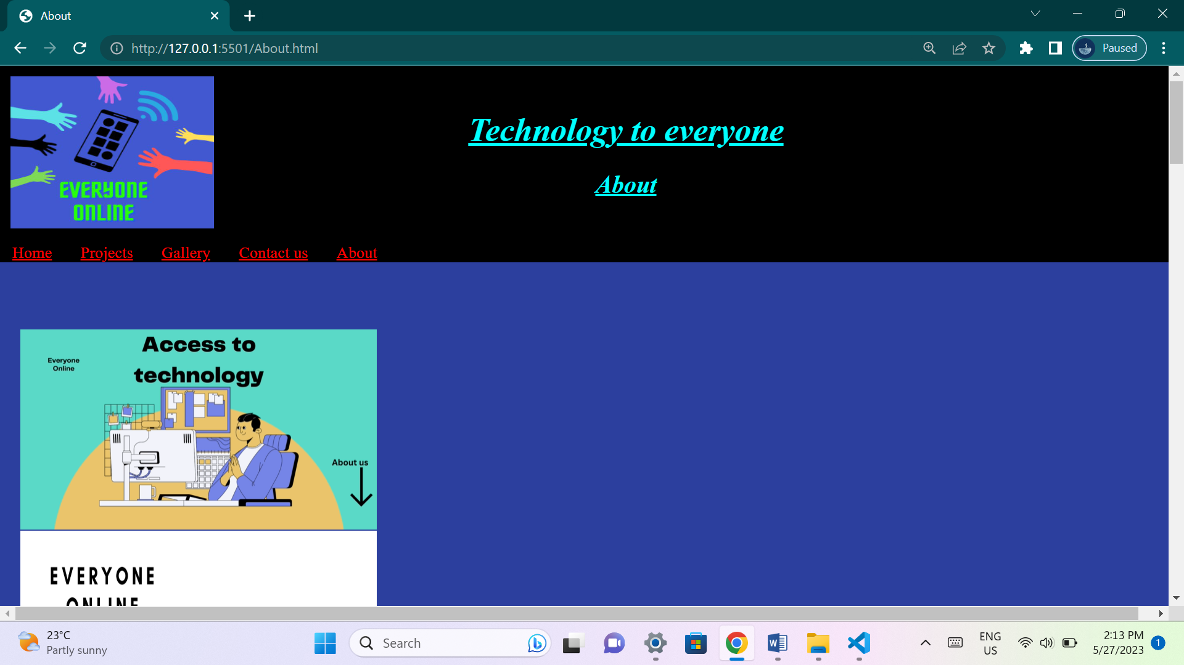

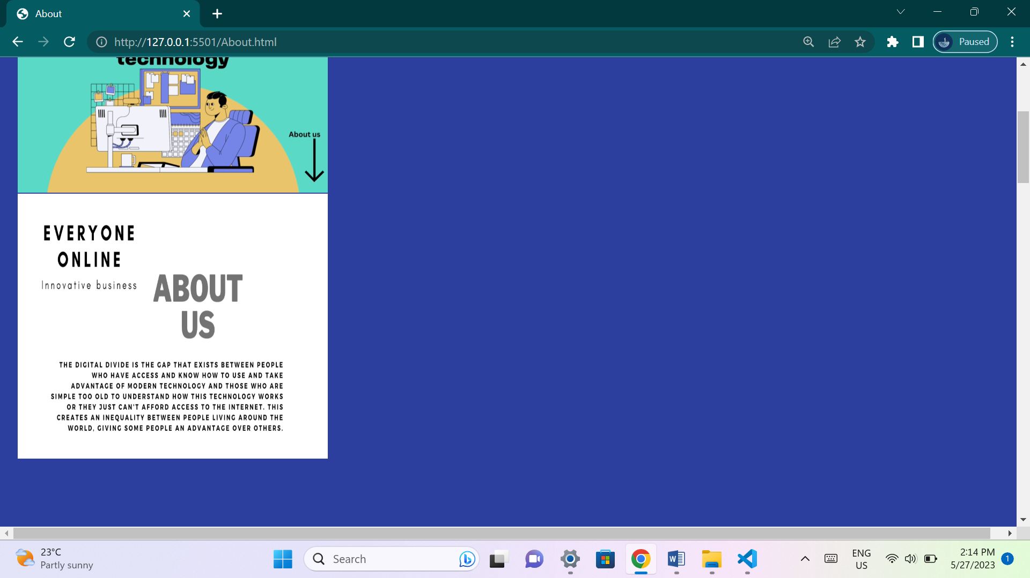

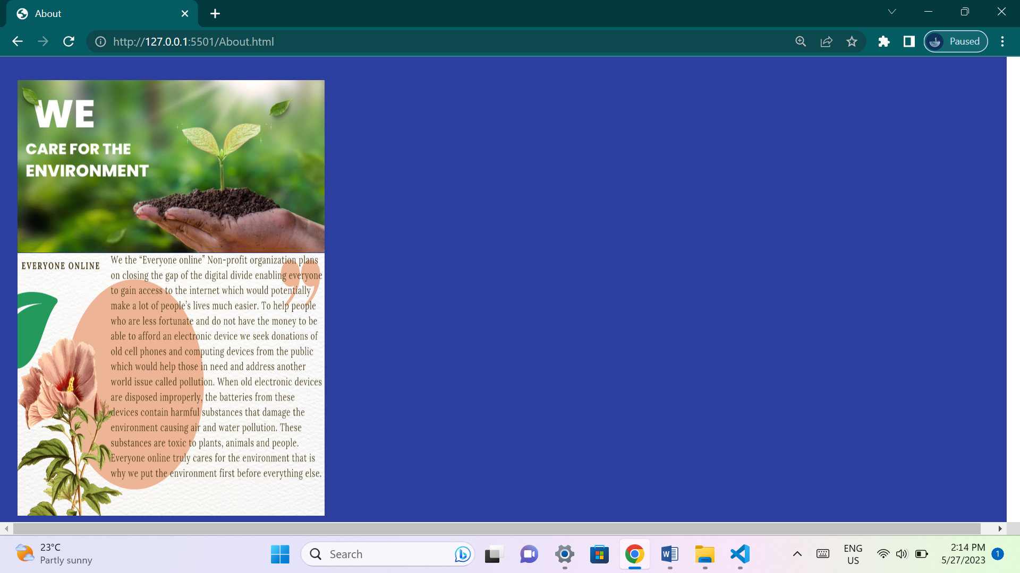

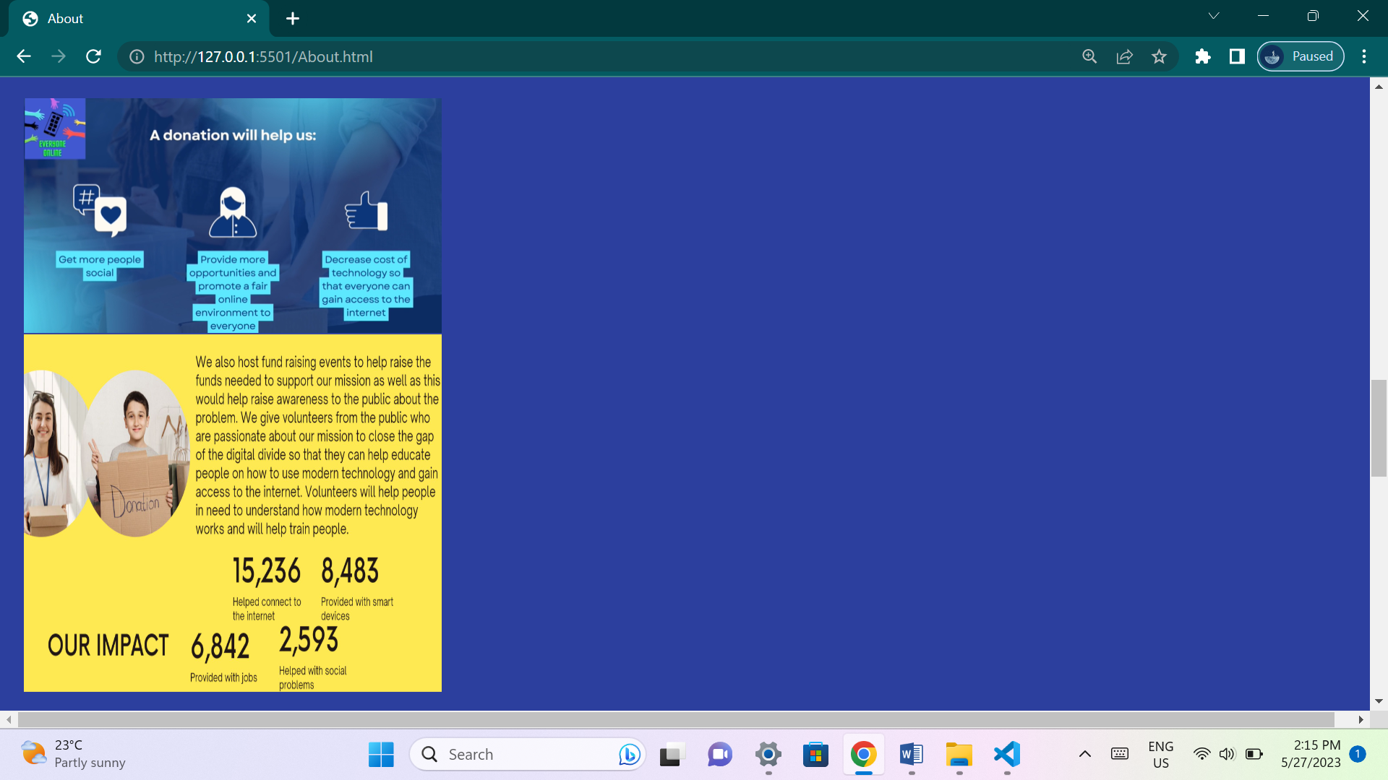

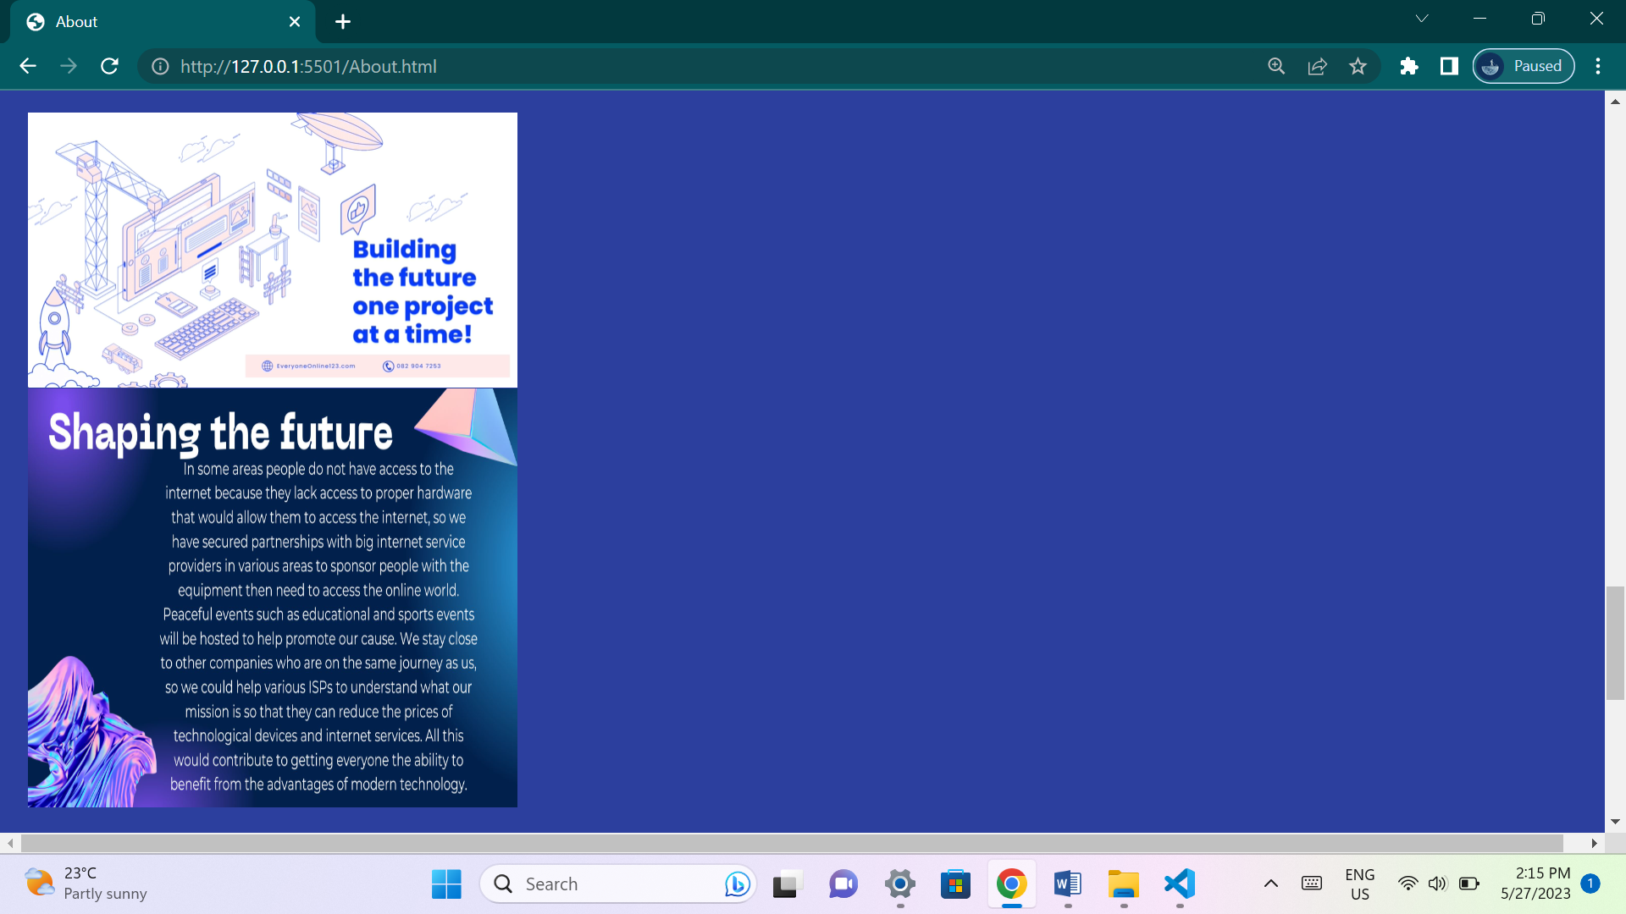

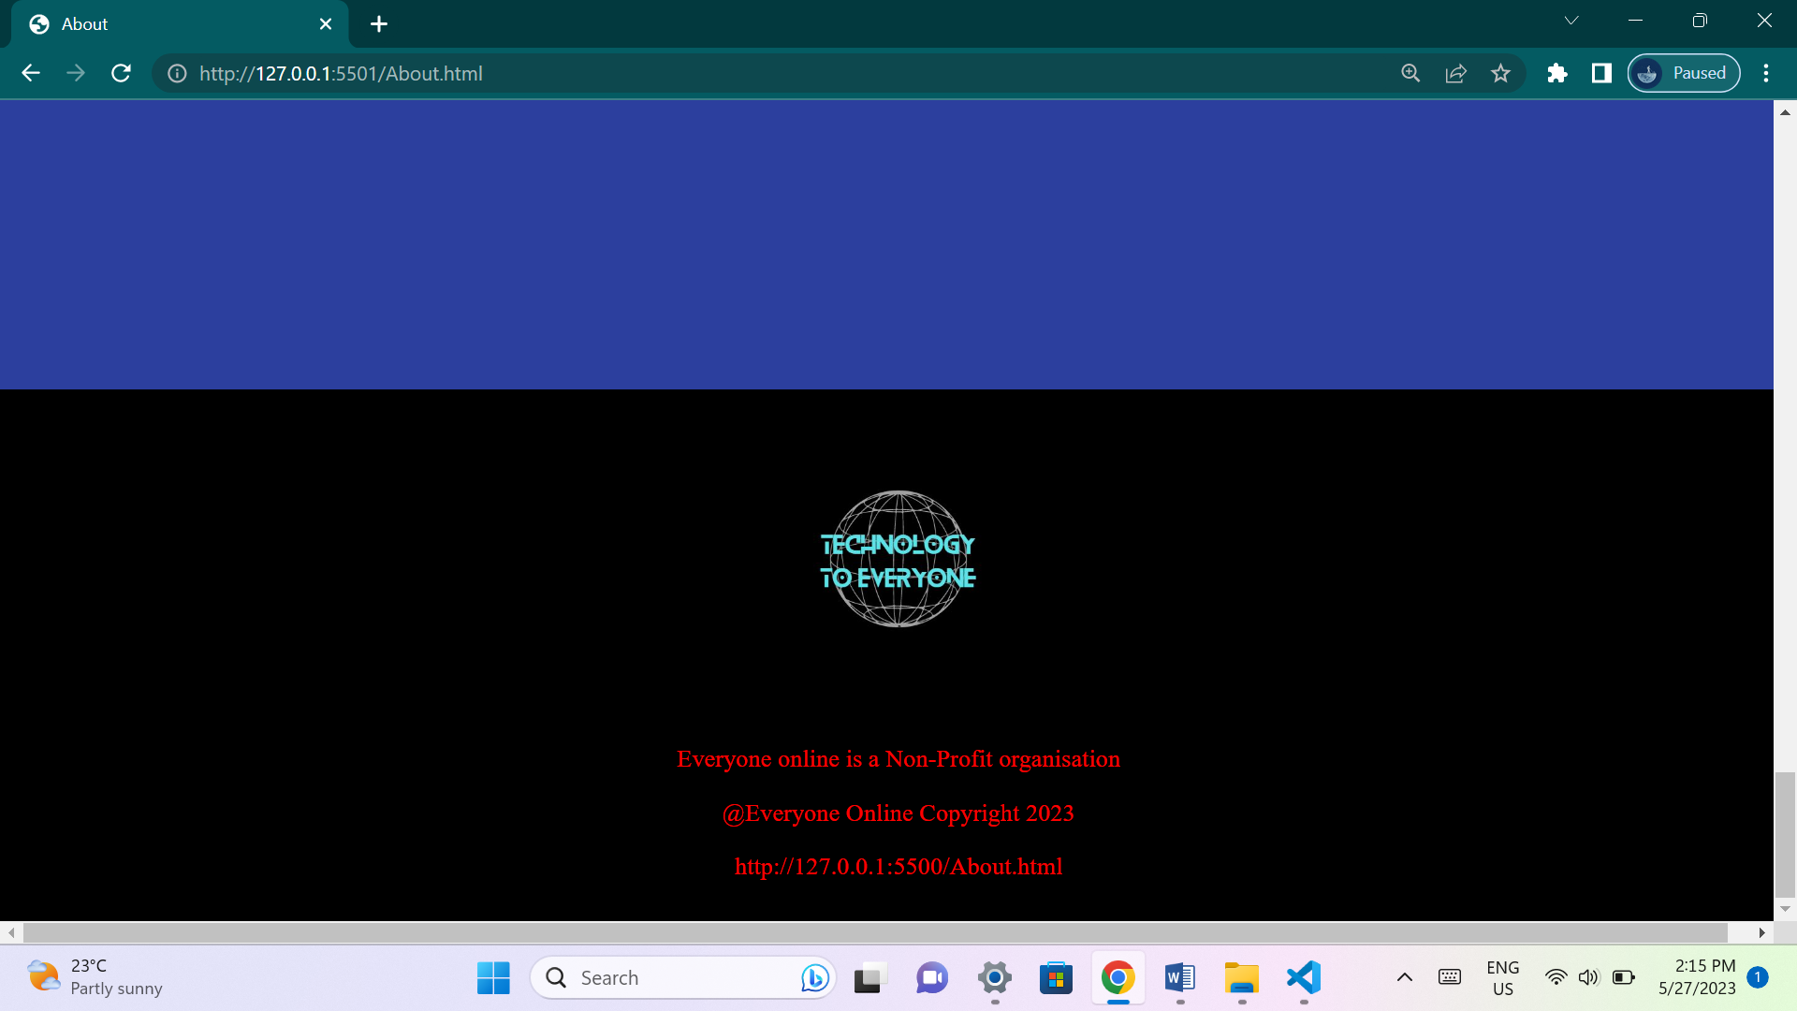

**This page will explain to the user what the organization is about. It will give users an idea about the organization goals and why the organization wants to achieve their goals.**

**Improvements in code:**

**The entire middle screen of all pages has been changed.**

**Added code:**

**Home.html:**

**New code has been added from line 65 to line 85.**

**4 Div tags has been added on lines 65, 70, 76, 82.**

**4 Video tags has been added on lines 66, 72, 78, 83.**

**4 Paragraph tags has been added to lines 68, 74, 79, 84.**

**4 links have been added to lines 69, 75, 80, 85.**

**Home.css:**

**New code has been added from lines 6 to 13, 62 to 66, 68 to 91.**

**Changes to code made on:**

**Line 50, height value changed from 100vh to 300vh.**

**Projects.html:**

**New code has been added from lines 72 to 92.**

**1 H3 heading tag added on line 72.**

**4 Div tags has been added on lines 74, 79, 85, 91.**

**4 Video tags has been added on lines 75, 80, 86, 91.**

**3 Paragraph tags has been added to lines 77, 82, 88.**

**Projects.css:**

**New code has been added from lines 6 to 41, 74 to 101.**

**Changes to code made on:**

**Line 75, terminated padding, height, width elements.**

**Gallery.html:**

**No changes.**

**Gallery.css:**

**New code has been added from lines 7 to 14.**

**Changes to code made on:**

**Line 53, Height value changes from 100vh to 100%.**

**Line 54, Width value changes from 100vw to 100%.**

**Contact.html:**

**New code has been added from lines 65 to 125.**

**2 Heading tags H3 and H4 has been added on lines 67, 68.**

**5 paragraph tags have been added on lines 69, 81, 83, 85, 111.**

**4 inputs have been added on lines 87, 90, 93, 96.**

**1 Button tag has been added to line 99.**

**A script tag with JavaScript has been added to lines 101 to 107.**

**Contact.css:**

**New code has been added to lines 6 to 37, 85 to 115.**

**Changes to code made on:**

**Line 74 to height component value from 100vh to 200vh.**

**About.html:**

**New code has been added from lines 63 to 77.**

**4 Video tags have been added to lines 63, 67, 71, 75.**

**4 Image tags have been added to lines 65, 69, 73, 77.**

**About.css:**

**New code has been added to lines 6 to 13.**

**Changes to code made on:**

**Line 49, height value changed from 100vh to 500vh.**

**Line 50, background-color changed from white to rgb(44, 63, 158).**

**Reference list for new website assets:**

**All new website assets have been designed using the canva application.**